Westbourne Housing Information December 2014
The following pages provide information on the current housing position in Westbourne that may not be easily available from publically accessible sources.
At the heart of the National Planning Policy Framework is a presumption in favour of sustainable development and an expectation that planning authorities use their evidence base to plan and meet the full objectively assessed needs for market and affordable housing. We are expected to deliver a wide choice of high quality homes, wider opportunities for home ownership and create sustainable, inclusive and mixed communities and in doing so “plan for a mix of housing based on current and future demographic trends, market trends and the needs of different groups in the community (such as, but not limited to, families with children, older people, people with disabilities, service families and people wishing to build their own homes)”. This involves identifying the size, types, tenure and range of housing that is required in particular location and reflects both local need and demand.

- Census information

Age profile

Source: www.neighbourhood.statistics.gov.uk

The above graph illustrates that there is a relatively low number of people aged 20-29 living within Westbourne compared to the rest of District and South East England; this is likely to be because people within that age band are having to move away for work and are unable to afford to live within the parish. It also indicates a relatively high number of people aged 45-59 compared to the rest of the district and SE England.

Chichester is an affluent District however, its population is ageing, the SHMA report and recent neighbourhood plan surveys indicate a very significant need for smaller housing for older people to downsize and starter homes for young couples wishing to set up home for the first time. The District relies heavily on the public sector for jobs and it struggles to retain and attract younger working age households. Its housing stock is biased towards more expensive, detached residences and it has too few well-paid jobs. Despite an overall increase of around 7000 in its resident population, the actual number of 20-39 year old residence fell between 2001-2011. Affluent older people do support a wide range of local jobs, but Chichester is becoming increasingly reliant on a dwindling pool of working age residence and a large number of in-computers to support its economy.
Tenure

The 2011 census information shows that Westbourne has a larger percentage of social/affordable rented units than the District as a whole. However in comparison to the other parishes within the District it is only ranked 20th highest, as some parishes have no affordable housing and Westbourne as a sustainable settlement would be expected to meet the needs of less sustainable settlements.

Westbourne, Chichester, South East England - tenure percentage comparison
Tenure Type | Westbourne | Chichester | South East
Owned | 71.6% | 67.2% | 67.6%
Shared Ownership | 1.6% | 0.9% | 1.1%
Social Rented | 16.3% | 14.9% | 13.7%
Private Rented | 9.0% | 14.9% | 16.3%
Living Rent Free | 1.5% | 2.2% | 1.3%

Source: www.neighbourhood.statistics.gov.uk

Bedroom stock (all tenures)

The below table illustrates the bedroom percentage composition of properties within Westbourne compared to the Chichester District and the South East;

Westbourne, Chichester, South East England - bedroom number comparison
Number of bedrooms | Westbourne | Chichester District | South East
1 Bedroom / studio property | 5.9% | 9.6% | 11.9%
2 Bedroom property | 32.1% | 28.0% | 26.2%
3 Bedroom property | 41.1% | 38.0% | 38.9%
4+ Bedroom property | 20.9% | 24.4% | 23.0%

Source: www.neighbourhood.statistics.gov.uk

This shows that there is a good variety of housing stock within the parish, however the number of 1 bedroom properties is well below average for Chichester and the South East.

- Westbourne market housing prices

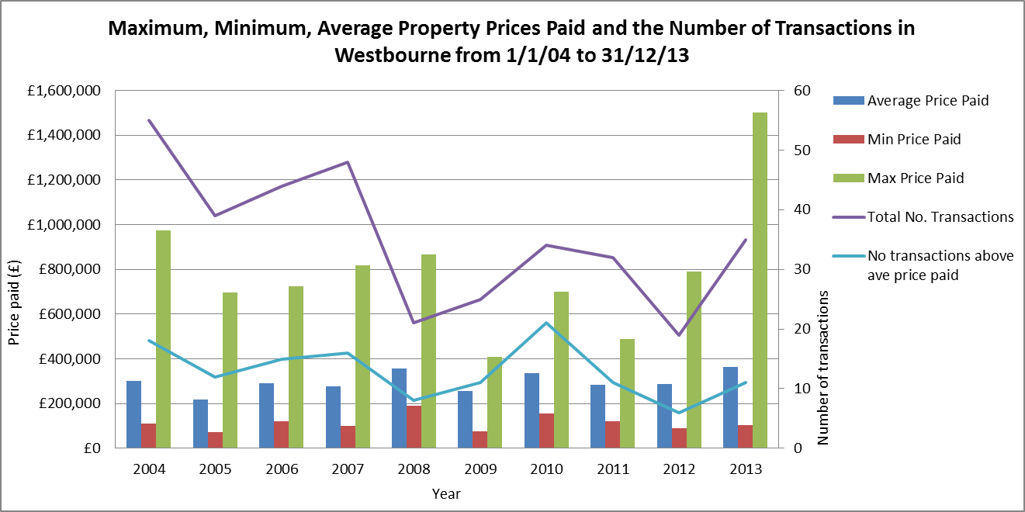
The below chart illustrates the average prices paid in Westbourne compared to the max and min prices paid and number of transactions that year. The UK is only now showing signs that it is exiting its 6 year recession, the average price paid last year for a property in Westbourne was £362,052 which is well above the price an average working household in Chichester would be able to afford (the average household income in Chichester £42,000). The highest paid price for a property was last year (£1,500,000). The minimum prices’ paid each year indicates that there are properties affordable for lower income families.

According to Zoopla Westbourne’s Zed-Index (the average property value in a given area based on current Zoopla estimates) is £332,408. There are currently 8 properties for sale with an average asking price of £351,666.
The below chart provides a breakdown of the average asking price per bedrooms and how many properties are currently available;
 | Average Asking Price | No. Properties
One bedroom | £120,000 | 1
Two bedrooms | £258,332 | 3
Three bedrooms | £322,490 | 3
Four bedrooms (+) | £396,650 | 1*

*1 property currently available – 6 bedroom house, asking price of £995,000

- The Strategic Housing Market Assessment (SHMA)

In 2012 the West Sussex coastal authorities commissioned a strategic market assessment to establish a strategic vision of housing supply and demand in both the social and market housing sectors. The assessment was undertaken using the government’s practice guidance and provides very important evidence for developing the council’s planning and housing policies. It uses a wide range of data, including census and local housing register. The completed report and its summary can be found on the council’s website at http://www.chichester.gov.uk/index.cfm?articleid=13613 .
Although the findings are not available on a parish level, many of them are broken down and reported on an area basis i.e. Chichester City, National Park, North East of the District and the South of the District. We would recommend that you would consider both the overall recommendation for Chichester District together with the information that relates to your area of the district in developing your housing policies.

SHMA Recommendations

It recommends that 70% of the affordable housing is provided as affordable rented homes and that 30% is provided as low cost home ownership. It also recommends that for strategic planning purposes the affordable rented homes are provided in the following mix;

Recommended affordable housing mix by size
1-bed | 10-15%
2-bed | 30-35%
3-bed | 35-40%
4+ bed | 15-20%

The SHMA recognises that when applying these recommendations to individual sites, “regard should be had to the nature of the development site and character of the area, and up-to-date evidence of needs as well as the existing mix and turnover of properties at local level.” In terms of the market housing the SHMA recommends the following mix;

Recommended Market housing mix by size
1 & 2 bed | 35%
3 bed | 50%
4+ bed | 15%

The district is attractive to well-off incomers moving into the district who can afford large houses. Developments with a disproportionate amount of four-plus bedrooms that do not meet local need are often proposed by developers and will be resisted by the council, though each individual site is considered in terms of need, existing stock and turnover. The SHMA market mix aims to best meet local needs while still providing an element of larger houses which are attractive to professional/entrepreneurial households who are important to the district’s economy.

- Local housing register information as at 06.08.2014

Chichester District Council and our registered provider (“housing association”) partners operate a choice based letting scheme whereby applicants must bid for homes and the household with the highest need who has been on the register for the longest time will be successful. Applicants wanting a home, or wishing to transfer, are assessed and their connection to the district verified and placed in bands A-D. Bands A-C have priority. A and B bands are assigned to people with acute housing problems. Most priority households are in band C, for instance those experiencing overcrowding. D bands are given to households considered not in housing need and would include adult children, even those living with a partner/spouse, with their own bedroom in the parental home. The full allocation policy can be found at: http://www.chichester.gov.uk/index.cfm?articleid=22367

Housing register information is used to assess local need, as households may have stated a local connection to a parish, or indeed several parishes, on their application. Need is however greater than these figures suggest. This is because people often don’t state any local connection, more applicants than just those with a stated parish connection are usually eligible to bid, and new developments encourage people not previously on the register to apply.

Westbourne currently has 26 households on the housing register who have stated a local connection to the parish, of which 10 (39%) are in bands A-C. 16 of these households have expressed an interest in shared ownership, but as they have had no financial assessment, this may be an unrealistic aspiration for some.

Housing register members' with a local connection to Westbourne; banding and bedroom needs as at 18.12.2014
Bands | 1 Bed | 2 Bed | 3 Bed | 4 Bed | Total
A | - | - | - | - | 0
B | - | 1 | - | 1 | 2
C | 3 | - | 1 | 4 | 8
D | 12 | 4 | - | - | 16
Total | 15 | 5 | 1 | 5 | 26

It must be noted that these figure are only a current indication of the need now and change is inevitable and it does not take account of a rising need over the period of your plan.
The below table illustrates the current members local connection to parish;

Housing register members' local connection to Westbourne
Band | Resident | Ex-resident | Employed in Midhurst | Next of Kin
A | - | - | - | -
B | 2 | - | - | 1
C | 7 | - | 1 | 1
D | 13 | 1 | 1 | 3
Total | 22 | 1 | 2 | 5

Of the 26 households 22 are currently resident within the parish (85%).

NB. Households may have more than one local connection to the parish.

- Current affordable housing stock and turnover

There are some 171 affordable/social rented homes in Westbourne (as at March 2014). The table below gives details of the existing affordable housing stock and turnover.

Westbourne housing stock and turnover as at March 2014
 | Total | reallocated 2007-2014 | reallocated 2013-2014
1 Bedroom | 37 | 21 | 7
2 Bedroom | 94 | 22 | 7
3 Bedroom | 40 | 8 | 0
Total | 171 | 51 | 14

The highest demand is for one & two bedroom properties and these properties have a much higher turnover. Since 2007 there have been 21 relets of the 37 one-bedroom properties, an average of 3 or 8% of this stock type, a year. Larger properties become available less frequently; there was only a 2% turnover of three-bedroom stock in the same period. Westbourne does not have any 4 bedroom affordable properties and there are 5 households with a local connection to the parish who have a 4 bedroom housing need.

- Housing stock lost to Right to Buy

Due to Right to Buy and Right to Acquire purchases over three decades, considerable numbers of social rented housing have been lost, increasing the demand on existing and for new affordable housing. Often it has been the larger, most attractive properties on larger plots have been sold. It is estimated that Westbourne has lost 95 rented homes through Right to Buy.

- Low cost home ownership

In the U.K. owner occupation is the tenure to which most people would aspire, providing security of tenure, self-expression and an appreciating asset. For those who cannot achieve this, social and private renting are the usual options and demand is high in both sectors with resulting high rents. Consequently there are many people who could manage monthly mortgage payments instead of rent, but who have difficulty getting a mortgage due to the required large deposits and inadequate mortgage/salary multipliers. As the District has an average house price to average salary ratio of 13:1 and most mortgage multipliers are usually 3 - 4½ times household income, there is a large affordability gap.

There are several low cost home ownership (also known as intermediate housing) options, the most usual are shared ownership and equity loans. There are also mortgage guarantee schemes offered through banks. Further details can be found on the council’s website:
http://www.chichester.gov.uk/housingtobuy

There is limited information on demand, as new development always encourages people who have not previously done so to register. Experience has shown that shared ownership homes usually sell very well in the district. Two bedroom flats and houses are the most popular and affordable, though there is also demand for one bedroom flats and three bedroom houses. Shared ownership values are based on market values. As Westbourne has a lower percentage of younger households within the parish, this will help local people, who may otherwise be unable to buy, to invest in a home of their own.

- Older persons / Life Time Homes

By 2030 it is estimated that the population of Chichester aged 65 or over will increase to 31.7% (based on 2010-based subnational population projections).Older people are more likely to under-occupy homes and under-occupation is therefore expected to increase. The growing older population will also result in growth in households with specific needs. Many of these needs can be resolved in situ, through adaptions to existing properties and the delivery of new properties that meet “lifetime homes” standards and can be adapted to households changing needs. However some of the growing older population will require specialist housing such as sheltered or extra care provision.

- Conclusion
Establishing future need for housing is not an exact science. No single approach will provide a definitive answer. The NPPF advices that plan makers should avoid expending significant resources on primary research (information that is collected through surveys, focus groups or interviews etc. and analysed to produce a new set of findings) as this will in many cases be a disproportionate way of establishing an evidence base. Instead you should look to rely predominantly on secondary data (e.g. Census, national surveys) to inform assessment which are identified within the National Planning Practice Guidance http://planningguidance.planningportal.gov.uk/blog/guidance/housing-and-economic-development-needs-assessments/methodology-assessing-housing-need/.
We suggest that the main issues you need to consider are;
- Affordable housing - There is substantial demand for affordable housing in Westbourne. We are aware you are looking to meet your housing numbers through identifying small windfall sites, it must be noted that due to changes in National Policy the parish will no longer receive affordable housing quotas on sites with less than 11 units. Exception sites could be considered to meet the local housing need (outside of your neighbourhood plan as the figures do not count towards your total housing numbers) if you were to pursue identifying windfall sites within your plan.

.

