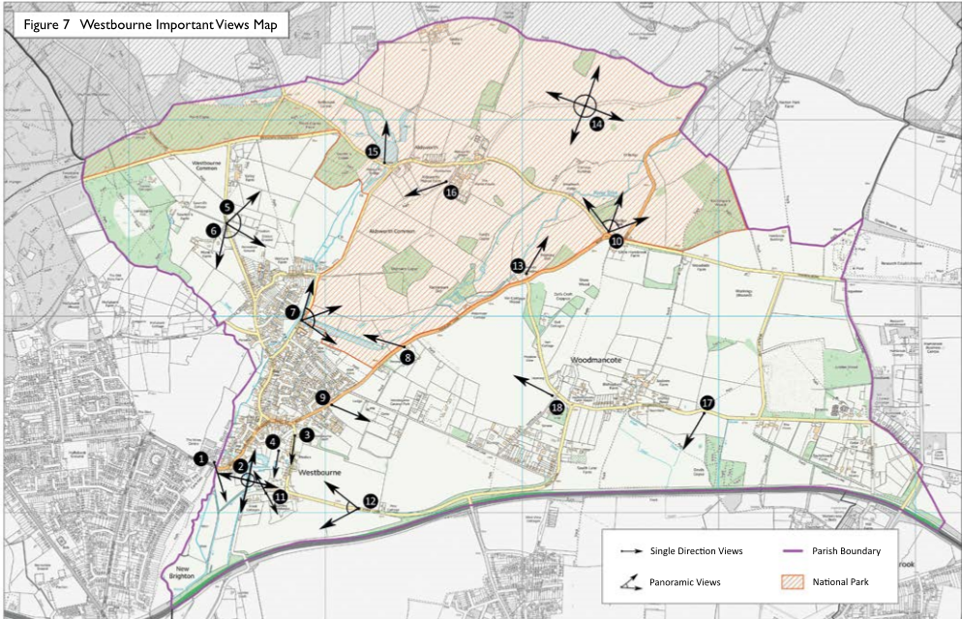
No on Map | Important Views - Observations from that View point;
1 | View from County Boundary with Hampshire looking over the open fields and numerous water courses of the River Ems including historic man-made streams and ponds used in the cultivation of watercress. Watercress production was a main source of farming and employment in the past. The streams and ponds are a prominent feature of Westbourne which the community has expressed a desire to retain in its current form
View 1 photos | 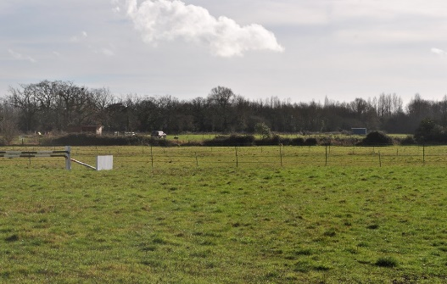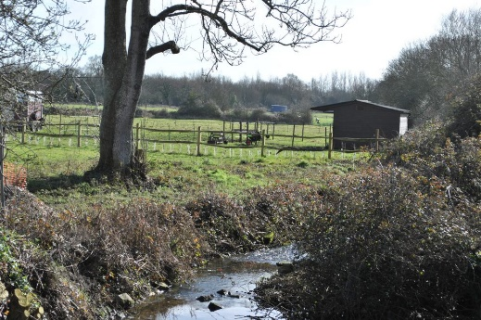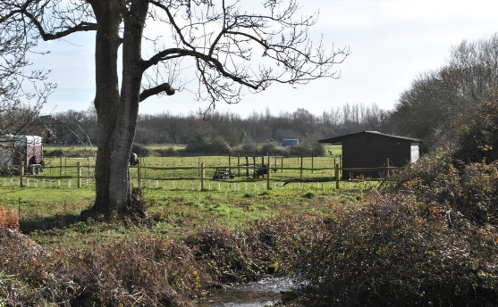
2 | 360 degree views from the footpath running along the watercourse of River Ems, off the main Westbourne Road close to the village centre. The view is over the West Sussex fields to the East, and West (towards the Hampshire border) and open fields looking South. To the North West is St John the Baptist church with its distinctive spire - a Grade I Listed building - a feature of Westbourne’s heritage. The stream running alongside the path is lined by indigenous trees and the views are glorious with abundant wildlife and a clear running stream. An ‘asset not to be damaged’ A peaceful walk on any day of the year, used by a large proportion of the wider community, dog walkers and ramblers alike.
View 2 photos | 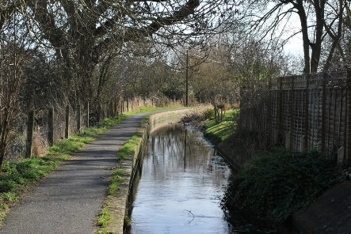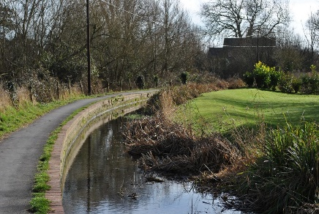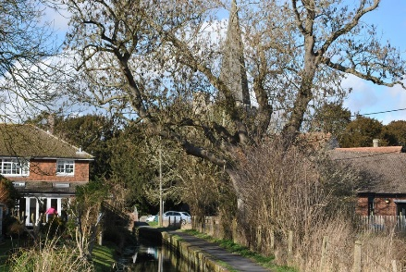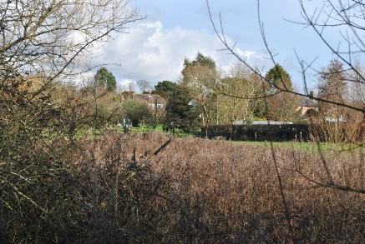
3 | Views South along White Chimney Row. This is one of the iconic views in the village which appears in many photos of the area;, a narrow entry to the village with historic buildings on the Western side and typical local flint and brick wall to on the Eastern side, The buildings, on the whole, have white-painted chimneys - hence the name ‘Whitechimney’. The wall has some large, ancient feature entrances. This is part of the Conservation Area with a mix of very old houses. A valued asset in Westbourne’s heritage
View 3  photos | 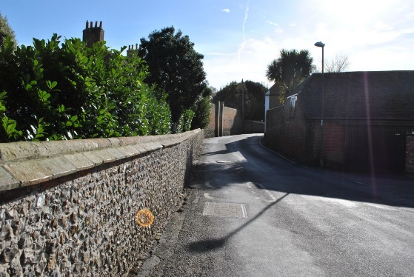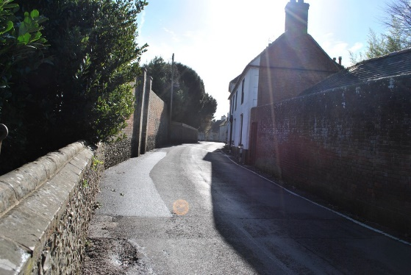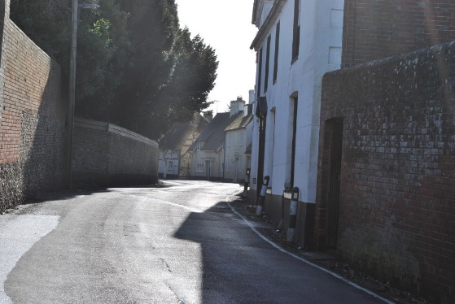
4 | This is a view from ‘New Road’ just behind the Square across the patchwork of what are now equestrian paddocks but were once part of the watercress production process. This demonstrates how the countryside reaches into the centre of the village,.
View 4 photos | 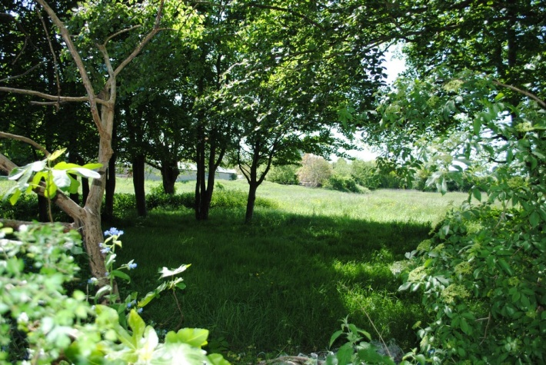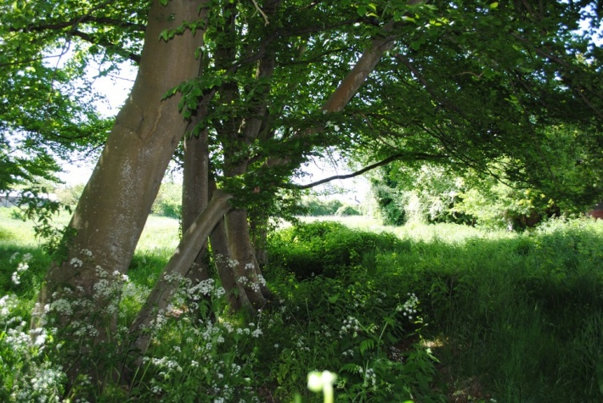
5 & 6 | Views are from the top of Monks Hill at the northern edge of the Village and one of the main routes into the centre. (5) To the East the view is over the village ‘Green’ an amenity space owned by the Parish Council and retained in perpetuity for the community of Westbourne. There is a small children’s playground, a car park and picnic benches. The area is used regularly by the community for recreation. From Monk’s Hill to the North East the views are across the Ems Valley to the South Downs National Park over Walderton Down and to the renowned Kingley Vale. The hamlet of Aldsworth, part of the Westbourne Parish, is in the depression between this point and the ‘Downs’. Slightly South of this you can see across to Woodmancote, the other hamlet of Westbourne Parish. Nearly all the buildings in the distance are hidden by large hedgerows and woodland - some classified as Ancient Woodland. (6.) To the South we look across the roof tops and old trees of Westbourne itself out to the Solent. Further round to the South West the views through the hedge are into open fields often visited by deer and other wildlife These views are of particular importance to the residents of Westbourne and to the wider community.
Views 5 & 6 photos | 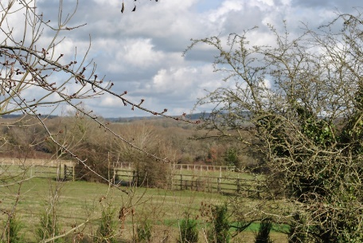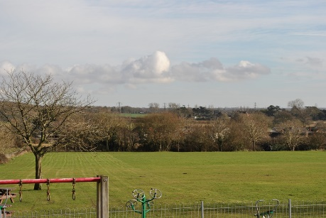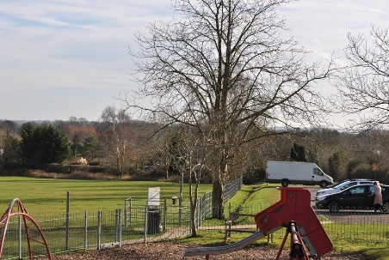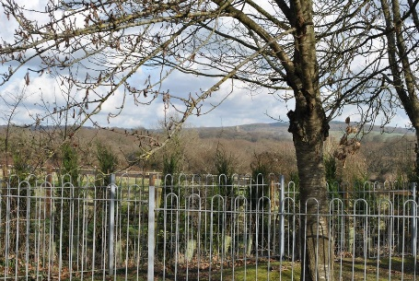
7 | River Street just North of the village Primary School. This is a typical country lane close to some of the main amenities of Westbourne. There are no visible footpaths but the route is widely used by walkers and horse riders as well as being a very pleasant place to drive along. The road runs alongside a tributary channel of the River Ems. The embankment drops down to the water’s edge where children can often be found paddling and walkers resting on the bench at the side. Looking north along the river you can see a beautiful old brick and flint bridge with the clear water of the chalk stream flowing beneath, especially in the winter months. In the summer the stream becomes a trickle but continues to attract an abundance of insects and wildlife. On the other side of the river bank are some of the flood plain fields glimpsed behind trees. Beyond the fields are some of the village dwellings. Opposite this view point is a Grade II Listed building called ‘Watersmeet’ behind which can be seen an old Canal/Mill pool, recently restored to its former glory. The ‘Canal’ attracts a variety of wildlife including swans, and kingfishers. To one side is a view of the school playing field and the fruit trees of the garden of Waters Meet can be seen to the North. Beyond is a patchwork of fields bordered with old hedges and trees. These views help to demonstrate Westbourne’s distinctive rural character.
View 7 photos | 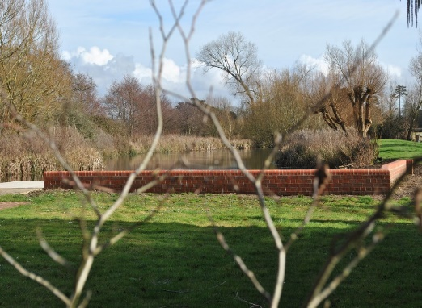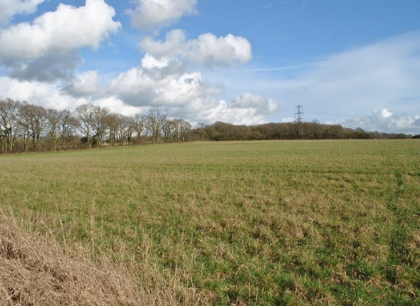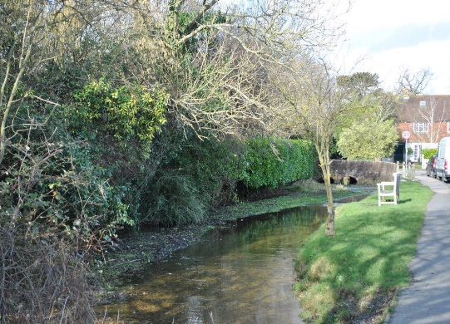
8 | Foxbury Lane just North East of the Village. From this view point you can look back across the meandering Ems River, with rushes and long grass growing close to the main channel. The fields, which serve as a flood plain allow views toward Waters Meet on River Street. The restored canal area and fruit orchard are visible. To the south is a patchwork of allotments and on the far side of the river cattle can often be seen grazing. North along the meander are some natural areas where wildlife thrive. Deer can be seen here regularly and they often use the area for birthing in the spring. The residents of Westbourne have been very clear that these are a series of views they wish to retain.
View 8 photos | 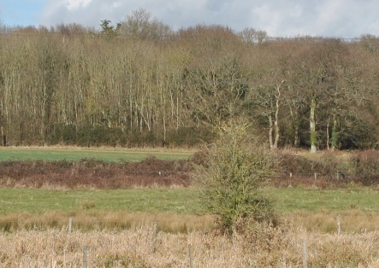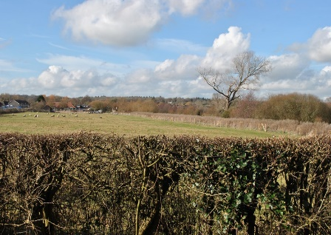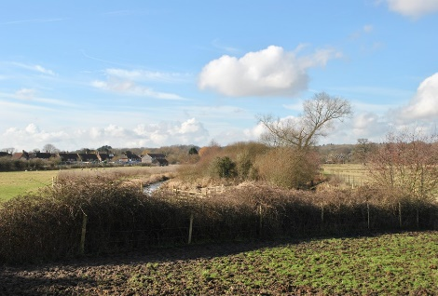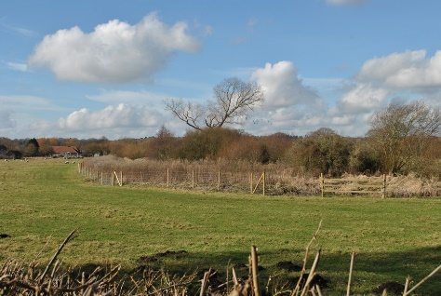
9 | Foxbury Lane close to Chantry Hall. This is where the development starts on the south easterly side of Foxbury Lane on entering the main village. The views from here are across equestrian fields (previously agricultural fields) to the Cemetery. The Cemetery is bounded by a low old flint wall. Within the grounds are numerous yew trees and a flint chapel. The Cemetery was built here away from residential property because of the theory prevalent at the time that sickness could be passed from the dead. Although the Westbourne Neighbourhood Plan has designated an area close to here for development, the Parish Council has taken into account the residents’ wishes that the open views to the Cemetery and the surrounding countryside along one of the main approaches to Westbourne Village are so significant that they should be retained. The importance of this view was highlighted by a Planning Inspector during a recent planning appeal hearing.
View 9 photos | 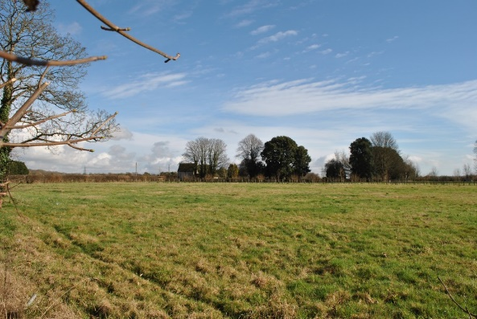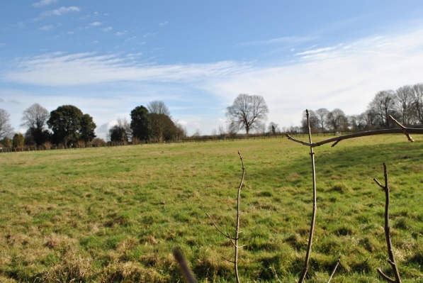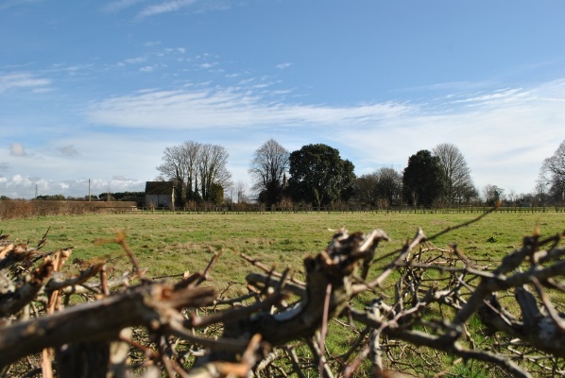
10 | Top of Foxbury Lane junction with Emsworth Common Road. This is outside the village heading into open countryside and the South Downs National Park. The view to the North West from here is over the Ems Valley with its old bridge on Emsworth Common Road and gently sloping hillsides rising round to the North to Racton Folly at Stansted park. The ‘Folly’, is a notable landmark. In the foreground is an area of Ancient Woodland, close to the valley floor. The Ems Valley continues North from this point toward Walderton and Stoughton. The area is in the South Downs National Park. To the East are views across to another area of ancient woodland also in the National Park. Further round to east and South east are views across equestrian fields with clumps of trees or woodland. A beautiful location to see the wonders of the rural area from along the footpath from Woodmancote.
View 10 photos | 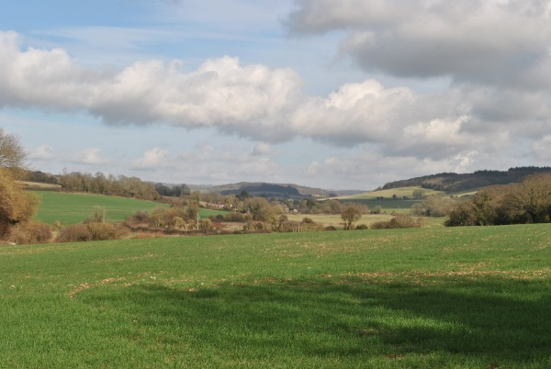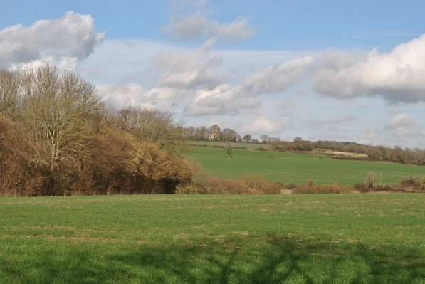
11 | Mill Lane North and South, just South of Westbourne Village. This is an unadopted road which is used by many visitors and villagers alike for walking and horse riding. From here you can look North across the rural landscape to the historic Village Church with its spire rising from the flint tower. To the South the views are of a rural aspect across well grazed fields, through gaps in hedges and across to further hedge lines with established trees. Predominantly there is only development on one side of the lane at any one time thereby maintaining a view over open countryside.
View 11 photos | 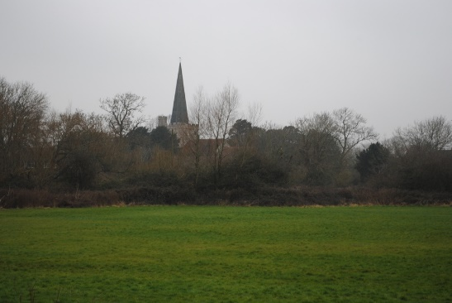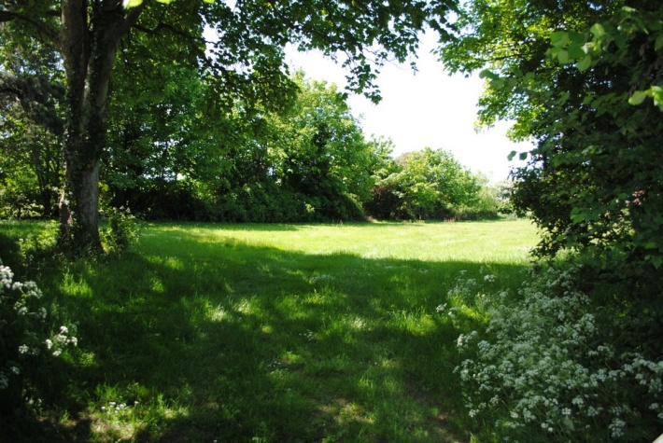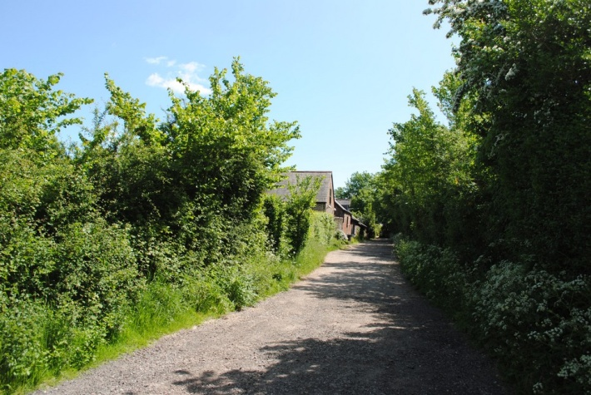
12 | Old Farm Lane, bottom of the hill. These are views experienced on the approach to the main Village along Old Farm Lane from the South East. They look over high quality arable land used in the main for planting of crops such as winter wheat and rape seed. They are large open expanses of fields, which contribute to the rural character of the Parish. The fields are frequently coloured swathes of yellows and gold, Falcons can be seen spiralling round on the thermals generated from the warm ground below. To the South there is a thick hedge of trees which disguises the main A27 so a remote but accessible rural landscape can be enjoyed within two minutes of Westbourne centre.
View 12 photos | 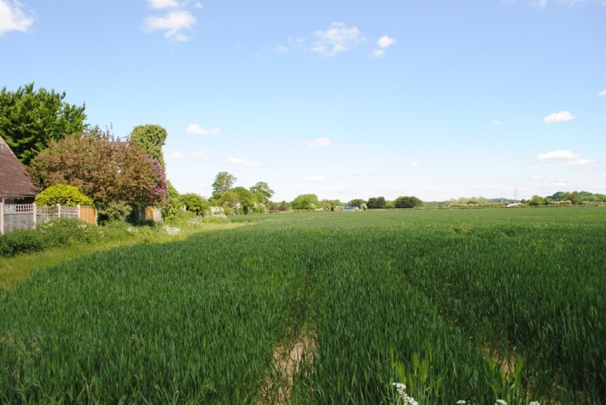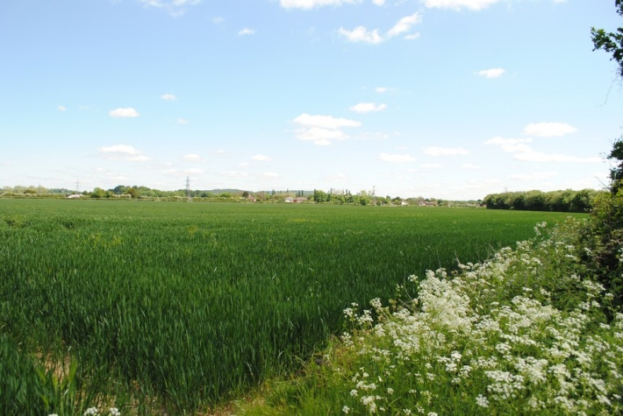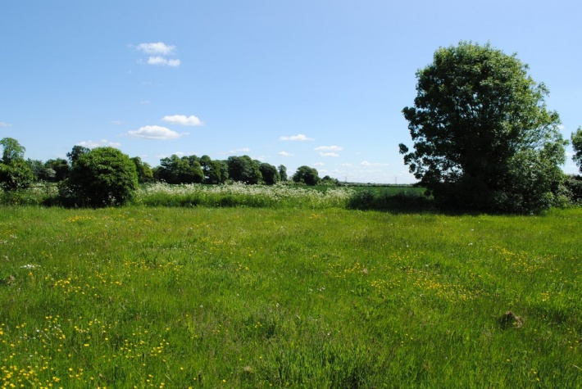
13 | Foxbury Lane Junction with Woodmancote Lane: The view revered from here is directly to the North, looking through an ancient wooded copse affording glimpses of Racton Folly.
View 13 photos | 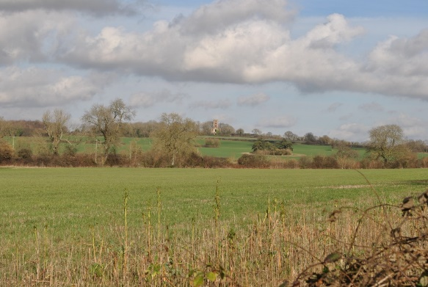
14 | This is a view from one of the single track unclassified roads just below Racton View Folly. It is a 360 degree view of the beautiful West Sussex Countryside taking in the monument and woodland to the North and West, and rolling fields with grazing cattle down to the Ems Valley to the South and East before arriving at an Ancient Woodland area close to Emsworth Common. The area is set in the South Downs National Park, close to Lordington where there are also a number of footpaths and bridle ways criss-crossing the area, a tranquil and beautiful location enjoyed by all.
View 14  photos | 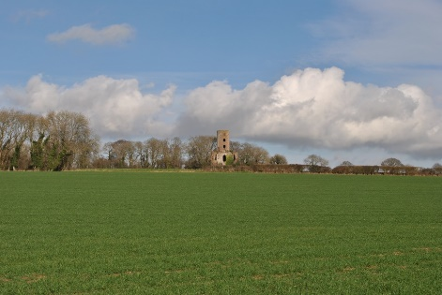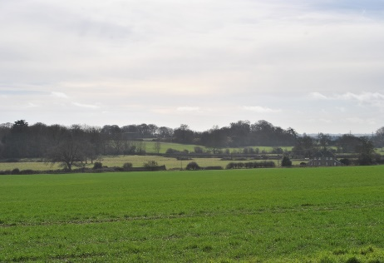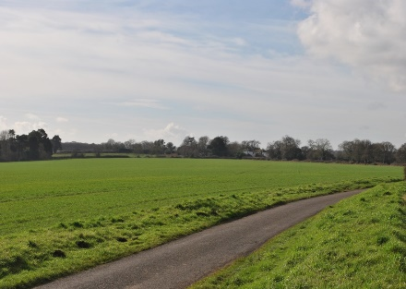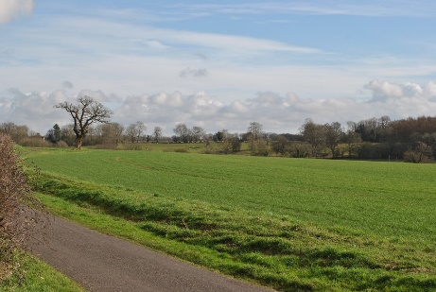
15 | Top of Aldsworth Common Road and junction with Emsworth Common To the North is one of the old man-made water cress ponds, no longer used in the production of watercress but now is a magnet for wild birds and animals. It has the appearance of a large pond with a water overflow which is actually one of the tributaries of the river Ems, Wild geese are often seen here as are deer. Cattle graze across the stream running alongside the ponds. There are well established trees giving a feel of a wooded area with open glades.
View 15  Photos | 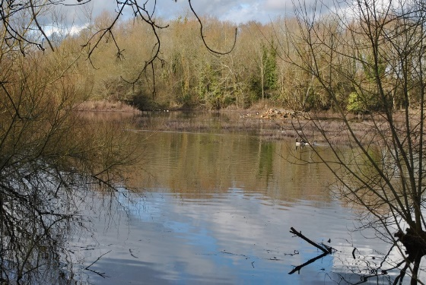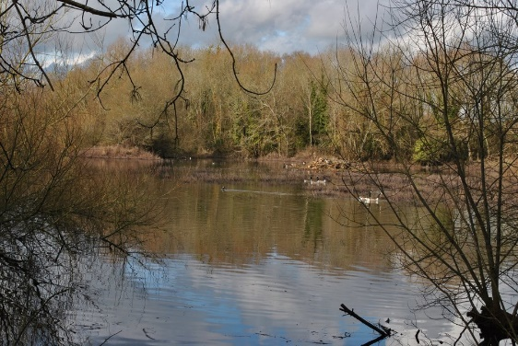
16. | View from high point in Aldsworth back toward Westbourne Village, shows the patchwork of equestrian holdings over to the Ancient woodland with glimpsed views of Westbourne. This view highlights the setting of Westbourne Village surrounded by countryside and shows clearly the separation of Westbourne village from Aldsworth and Woodmancote.
16. Photos | 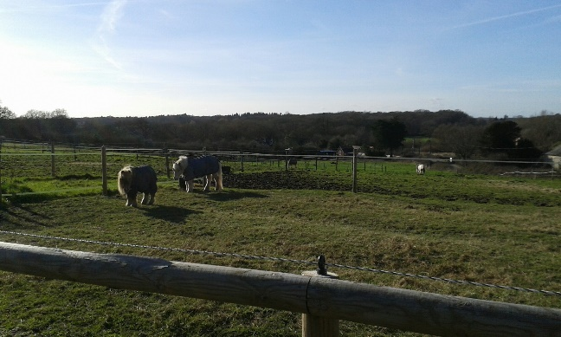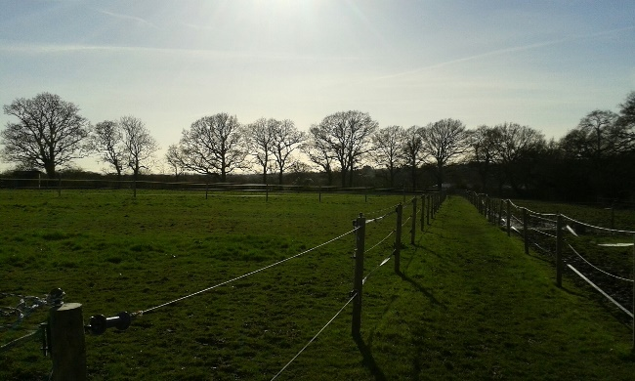 | 17. Photo | 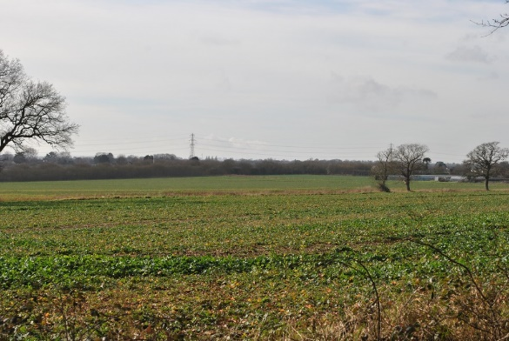
17 | Woodmancote Lane heading into the hamlet of Woodmancote approx. 300m from Marlpit Lane. This is quite an elevated position from Westbourne Village, and although it is a single-track road it is the main road through Woodmancote. From here the views are across the rural fields of Westbourne where crops are generally grown. The fields are large and open. Glass houses can be seen in the foreground and the view then extends across the coastal plain, over Hayling Island and to Portsmouth, Hampshire in the distance. Views are far- reaching and the landmark of Spinnaker Tower in Portsmouth is clearly visible on a clear day. The scar of the A27 is hidden in a tree line so little development is seen before Portsmouth. The road, as well as being a through route in Woodmancote, provides access to Westbourne from the East. The views are enjoyed by equestrian users, cyclists on the Southern Cycle path and walkers using the various footpaths and bridleways.
18 | Woodmancote Lane, junction with Duffield Lane. The views from here are to the South West, across open farmland used for crop growing toward the main conurbation of the Village. The steeple of the Church can be seen along with the roofline of some of the dwellings. Often deer and wild birds can be seen on the farmland. A line of trees hides other development between this point and the village. This lane is the main Public Right of Way from Westbourne Village to Woodmancote used regularly by pedestrians. It is also used by ramblers and cyclists. The undeveloped views from here are of importance to the local community and are considered worthy of protection.
View 18 photo | 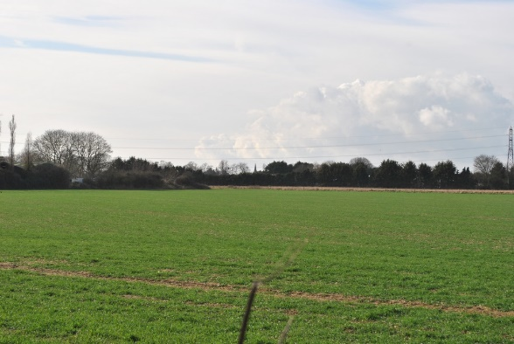
19 | North Street looking West along the route of the river Ems. This is a flood plain, which houses flat meadows, mainly for equestrian purposes. In the distance the trees generally disguise the houses at Emsworth beyond. In recent years the view has been somewhat compromised by the positioning of a dilapidated caravan in the field by the road. However, it is a vew that the Parish Counci is endeavouring to protect at the request of local residents.
View 19 photo | 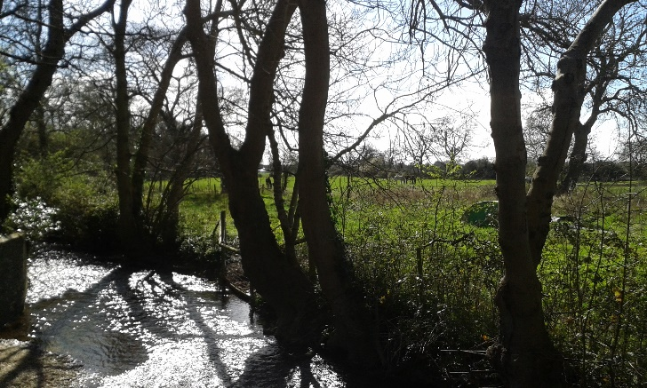

Most of the photos have been taken in the winter months and the detail is not of sufficient clarity to pick out many of the icons out referred to such as the Solent in Views 5 & 6 or Wildfowl on 15 or Spinnaker Tower in Portsmouth at 17.
The points identified as important views were initially based on a previous version of the Village Design Statement (VDS) which was created long before the inception of the concept of Neighbourhood Plans. The VDS was created by a group of residents and was the subject of widespread consultation with the wider community.
During initial work on the Westbourne Neighbourhood Plan, the community agreed that the Village Design Statement should be reviewed and updated to be read alongside the Westbourne Neighbourhood Plan. During the review process, the WNPSG reviewed all the views which were included in the first edition of the VDS and considered additional views. The VDS was edited accordingly and subjected to the same consultation process as for the WNP.

