This map depicts the areas where the Parish Council, in conjunction with the Westbourne Neighbourhood Plan Steering Group and the community as a whole believe that Gaps should be retained. Westbourne is sandwiched between the Chichester Harbour Area of Outstanding Natural Beauty, to the South and South Downs National Park, to the North. It is important that Westbourne should retain its own identity as a rural West Sussex Parish while enhancing the two adjacent, nationally important sites
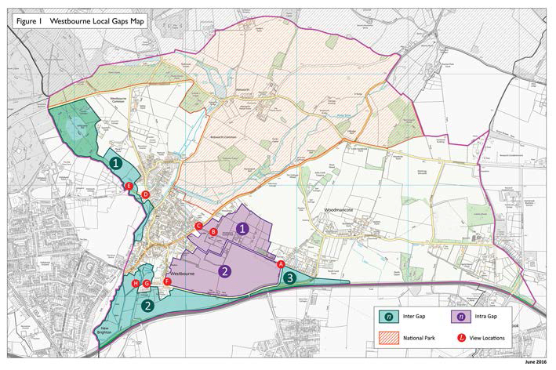
Fig 1

The intention is that the Gaps will assist in retaining the characters of the individual areas, maintain the open vistas and provide open space for walking and observing the varied and abundant wildlife and fauna. In order to achieve this aim it is essential to prevent the coalescence of Westbourne village with the Hamlets of Woodmancote/Aldsworth, the Borough of Havant and Southbourne Parish. There are many rural walks, bridle and cycle paths within these Gaps which enhance the amenity for the many people using them.

Westbourne Parish is centred on the River Ems which attracts many animals, birds, insects, various invertebrates and some rare plant life which has grown up on the banks of the clean chalk stream water of the river. The patchwork of fields separated by hedges is characteristic of a small West Sussex village. The retention of hedgerows is to be preferred to the installation of fences in order to continue to attract abundant wildlife, especially nesting birds. The Gaps will assist in providing corridors for free movement of the wildlife like deer. The habitats also provide valuable areas where slow worms, snakes (adders and grass), water voles, birds and bats live. The list is extensive
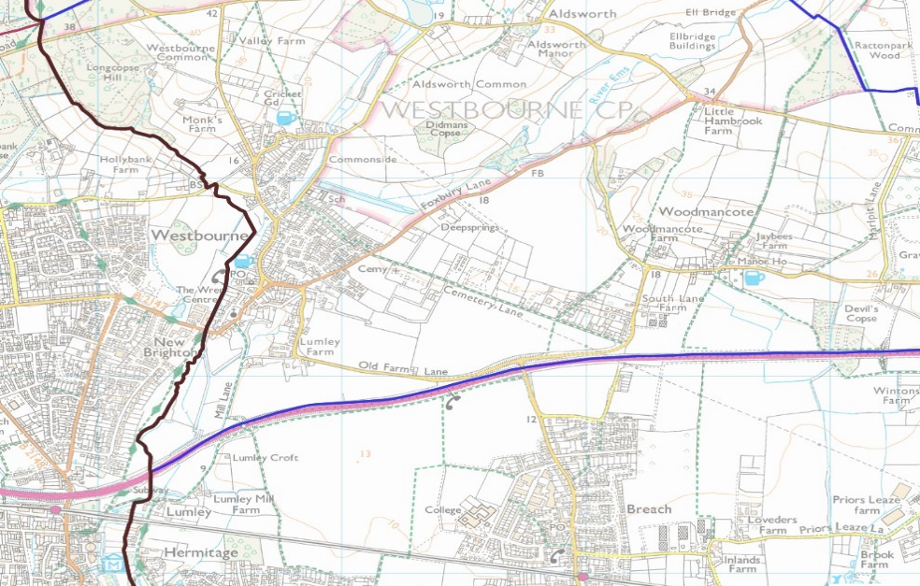
These are some of the significant features making Westbourne the attractive and desired place it is today. These are valued by all who live there and visit and the residents have indicated that they would like the surrounding countryside to have a level of protection similar to that of Green Belt around major cities. These Gaps will protect the environment against inappropriate over-development. The gaps identified previously were contained within Strategic and Locally Designated Gaps and, faced with the possibility of the reduction or loss of countryside to development, the community have has expressed the desire for locally important Gaps to be retained.

Fig 2

There are 2 types of areas which the Westbourne Neighbourhood plan could influence;
- The Inter Gaps those surrounding the Parish and;

- The Intra Gaps those within the Parish

Figs. 2&3 show the wider overview where built areas are encroaching on the Parish.
It is important to appreciate this Plan has no influence on the area outside the parish boundary, which makes it all the more important that this plan controls the Gaps identified within the boundary.
The 2 different types of Gaps are identified on the plan in different colours, the Inter Gaps in purple and Intra Gaps in turquoise.

Inter Gaps;
Figure 2 shows the overview of Westbourne with the urban part of Emsworth (New Brighton) to the South West, Hermitage in the Southbourne Parish to the South of Westbourne Village itself and Southbourne, just to the south of Woodmancote.
- It shows the urbanisation of areas approaching Westbourne especially around the village itself, from Hermitage and Emsworth in the Borough of Havant in Hampshire.
- One issue here is that the boundary with Emsworth is not only with Havant Borough but is also the County Boundary so influence of Westbourne PC and Chichester District Council over development in this area is further reduced. There are currently plans to build 260 houses on the Havant side of the boundary which will have a significant impact on the gap, thereby encouraging coalescence of the two communities.
- To the West and North West of the village, a section of the village is either on the County/Borough boundary or very close to it. Recent housing on the Hampshire side on the Redland Grange Estate has eroded part of the Gap here, so it is important that the remaining Gap within Westbourne be afforded protection.
- To the South the Parish Boundary runs along the major A27 route. Between this and Westbourne Village is one of the best rural walks in the area running alongside the river Ems, as well as a haven for wildlife: a number of Salmon Par (young salmon) were identified last year for the first time. This is the furthest west they have ever been found along the south coast.
- Further along the A27 to the East immediately South of Woodmancote is the Parish Boundary, and on the other side of the A27 is Southbourne. It is considered appropriate to retain a Gap between the two areas in order to preserve the identity of Westbourne as a rural parish.
- The approach to Westbourne village along Old Farm lane is bordered on both sides by fields giving the sense of rural detachment. Residents, in consultation, have reinforced their wish for the rural approaches to the Parish to be retained.

Intra Gaps;
Figure 2 also shows to the East of Westbourne Village ‘Cemetery Lane’, an unadopted road and well used footpath which links the Westbourne village to the hamlet of Woodmancote.
- Cemetery Lane is straddled by a patchwork of fields, the Cemetery at the Westbourne end and established dwellings at the eastern Woodmancote end.
- The Cemetery is a Non-Designated Heritage asset, it was laid out in its current position in Victorian times as it was believed at the time that illness and disease could be transmitted from the dead (Miasma theory), so it was placed outside the village settlement with an open area retained all round it. It is very important that this separate, open area is maintained, so as not to detract from its historic character and appearance. As a consequence, this area forms an important part of the Gap here.
- The Cemetery is still in use for burials by both Westbourne and Southbourne and people regularly visit for a peaceful, tranquil and reflective period. The Cemetery by nature is open and sits well in its rural position. The purpose of the Gap would be to ensure the continuation of this tranquil spot and to protect it against inappropriate development.

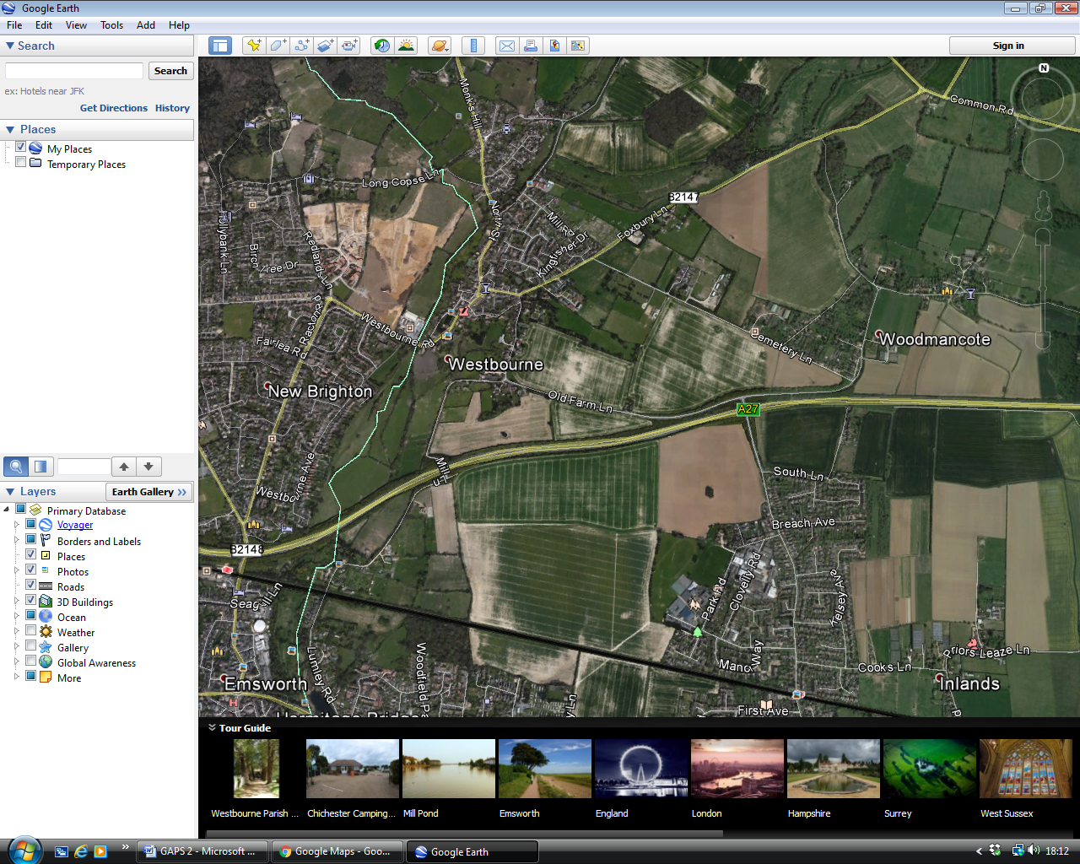

Fig 3 shows the aerial overview of the village and surrounding area.

- Between the Cemetery and Westbourne village is the Chantry Farm field where a small development in the plan has been identified but in considering this development it has been placed in such a way so the Gap can be retained.
- The Chantry development field is also one of the main gateways along Foxbury lane into Westbourne Village. Westbourne residents have indicated through consultation that they wish to retain the rural approach to the entrances to the Parish
- Westbourne Parish Council has been disturbed recently by a plethora of applications by the GTTS community for the construction and development of Gypsy and Traveller sites in this area. In addition, illegal commercial activity is taking place on sites on Cemetery Lane. In response to residents’ direct requests and to comments made during the public consultation process, the Parish Council seeks to bolster its objections to these developments by reinforcing the countryside designation of this area by the creation of a local Gap.

To the North of Westbourne Village is Aldsworth; however, this is in the SDNP which affords the area special protection. Therefore, it is considered unnecessary to create a separate Gap in this area.

Inter Gaps---Separation of Westbourne Village and Hamlet of Woodmancote within the Parish Boundary from external influences, such as New Brighton, Emsworth and Southbourne.
Inter Gap 1. --- Area North West of Westbourne Village, protects the village from coalescing with development over the County Border in Hampshire. (Havant Borough) It is a mixture of deciduous woodland, a patchwork of fields used for equestrian activities and some fallow land previously used for keeping pigs. There are large trees and where the lane runs through it the edges are made of thorn hedgerows ideal for nesting birds and wildlife.

Inter Gap 2. --- Area South of Westbourne Village covering Mill Lane area, this protects from pressures across the county boundary from Emsworth to the West and also Hermitage, part of Southbourne Parish, to the South. This incorporates some of the most important animal habitats and a footpath for peaceful walks to and from Westbourne along the River Ems to the coast. Water vole, deer and bats can all be seen regularly. The West of the river is used for alpaca rearing and to the East of the footpath and river is crop farmed land. Where the fields meet the Lanes, the boundaries are of hawthorn to the main with small sections of open post and rail fence. Some of this is considered Ancient Hedgerow.

Inter Gap 3 --- This land incorporates the eastern end of the field south of Cemetery Lane and a narrow section of the field East of South Lane in Woodmancote; part is cultivated field, both open aspects and provides the open feel of the rural foothills of the South Downs. It maintains a gap to prevent Woodmancote joining up with dwellings in the Southbourne area just south of the A27. South Lane was annexed when the A27 was built, this field is now bound by established Hawthorn hedging.

Intra Gaps--- Separation of internal communities within the Parish
Intra Gap 1 --- A patchwork of fields to the North of Cemetery Lane providing an important Gap maintaining separation of Westbourne village from the Hamlet of Woodmancote. There are a number of equestrian fields set with a mixture of crops and fallow land. The area has abundant wildlife including slow worms (legless lizards) snakes, bats and deer. Cemetery Lane is an unadopted lane not well used due by vehicles to its poor condition but is a well-used footpath. Both sides have high thorn hedges with sporadic gaps providing views toward the South Downs and across the open fields.
The Cemetery; it is a Non-Designated Heritage Asset and is highly valued by the community. It is kept manicured as a working Cemetery, There are several large yew trees in the grounds and to the main, its boundary wall, along Cemetery Lane, is the typical flint wall associated with West Sussex.
The Chantry Hall/Foxbury lane Field has been identified for a small development of 6 houses. The proposed boundaries of that development will not have an impact on the purpose of the Gap. The developer will be required to improve the landscaping so it fits well

in its surrounding. The Gap around the Cemetery will thus be enhanced and protected from further development and the entrance to Westbourne Village will retain its rural appearance. Most of the thorn hedging will be retained along with mature trees.
Part of the area, the Cemetery and its separation is designated a Green Space.

Intra Gap 2 --- This is the area south east of Westbourne Village between Old Farm Lane and the Cemetery. It will maintain the open rural views on approach to the village from the South East along Old Farm Lane; it links to the Cemetery, protecting the valuable open area around it assisting in preserving its character. Many of the views across the fields here are open but there are sections of high thorn hedging, which also provides a valuable wildlife habitat and bio-diversity corridor.
The open crop-cultivated farm land to the South of Cemetery lane forms a rural gap between Westbourne village and the separate and distinct hamlet of Woodmancote. However, it also protects the Woodmancote area from coalescence with Southbourne to the south over the A27at this point the boundary is high hawthorn hedging which straddles both sides of South Lane.

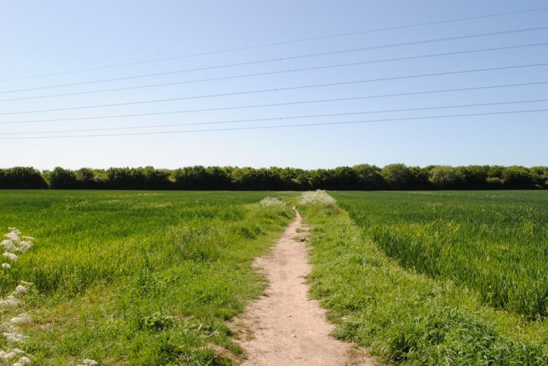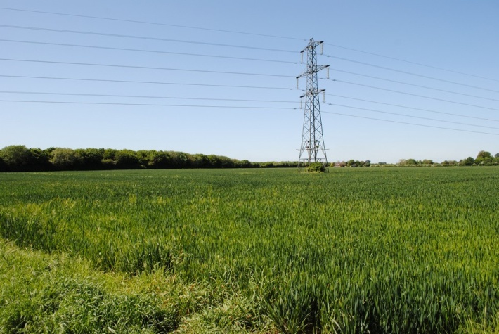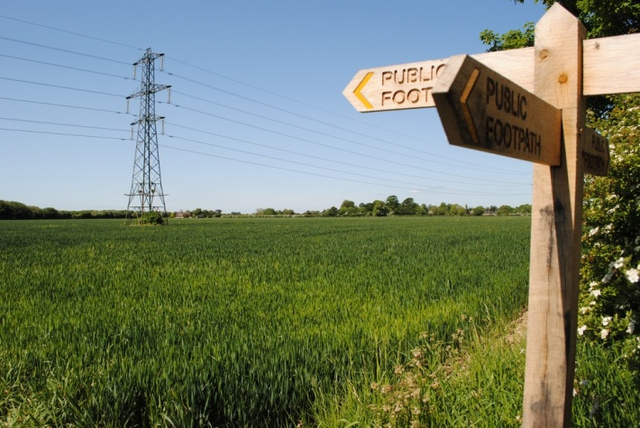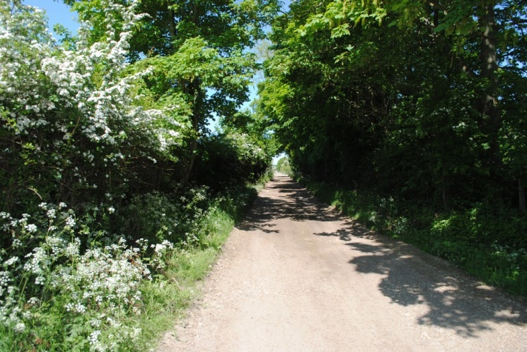
Above: Intra Gap 2; Views from and of Cemetery Lane Junction Duffield lane above
Woodmancote
Below: Intra Gap 2; Views along Cemetery Lane from location of Harwood below
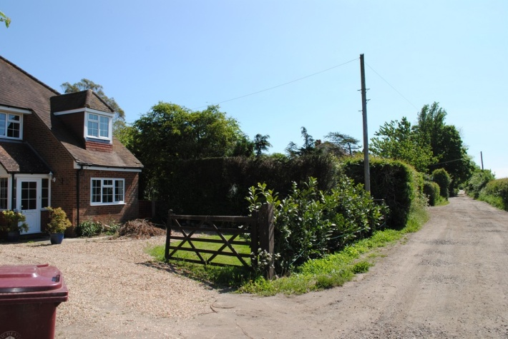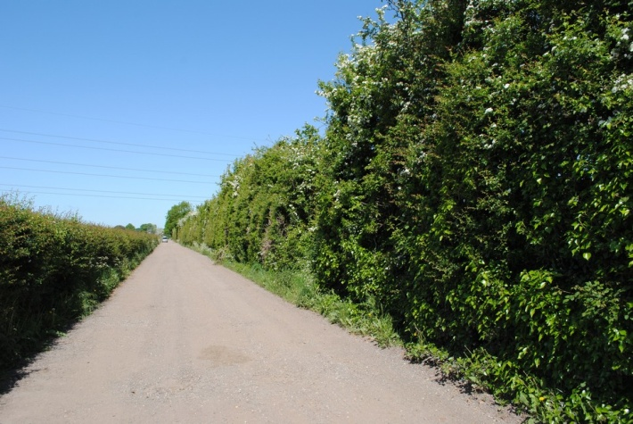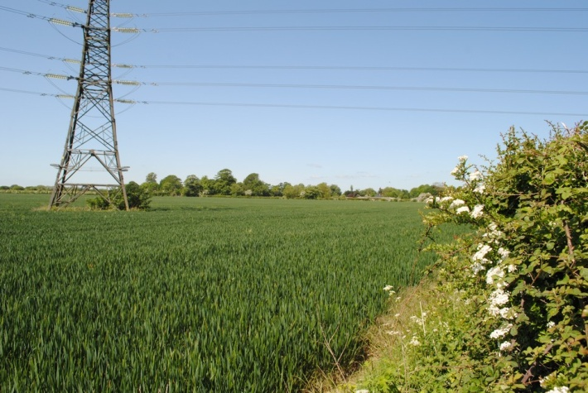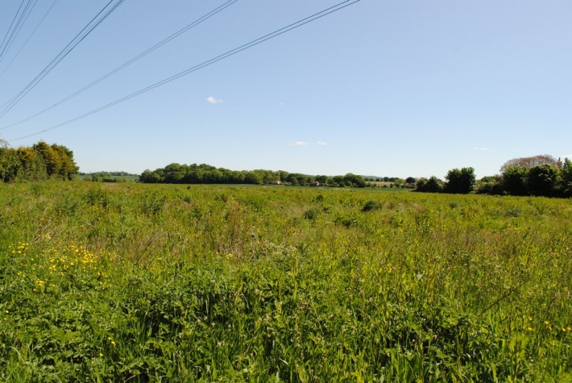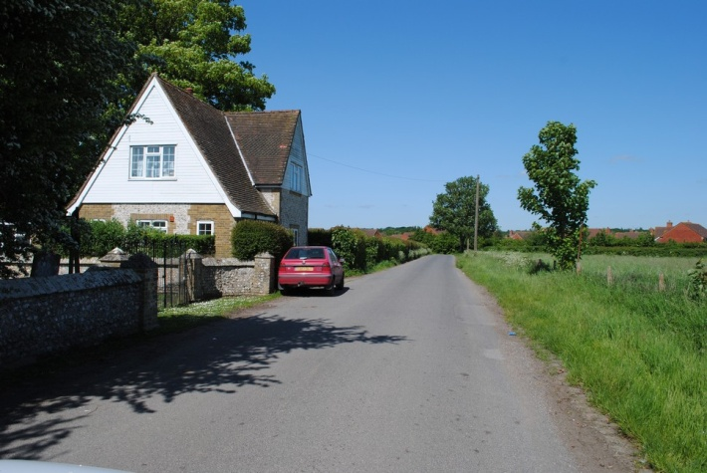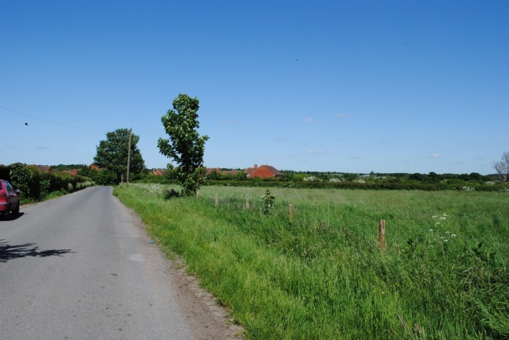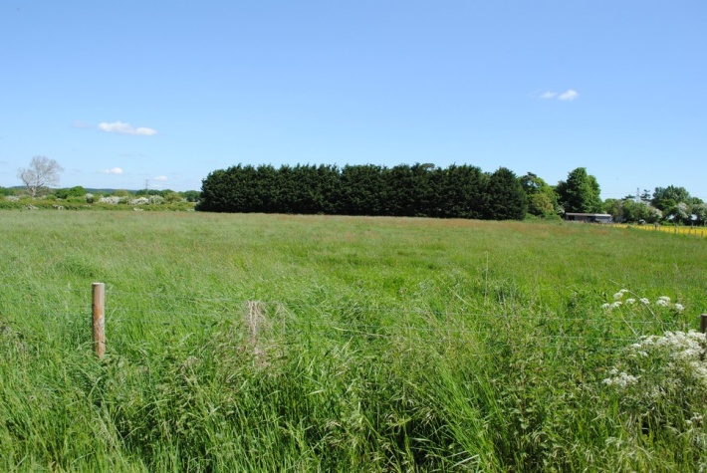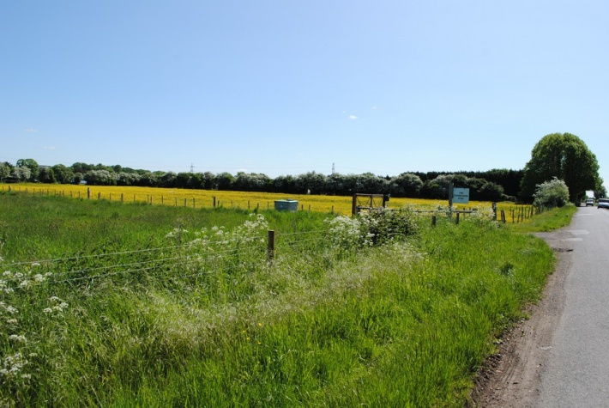
Above; Intra Gap 1 Cemetery Lane at the Cemetery; top 2 views toward Westbourne lower 2 into fields opposite

Below: Intra Gap 1; two views up Cemetery lane from Westbourne toward the Cemetery, bottom 2 along Foxbury lane toward the built environment
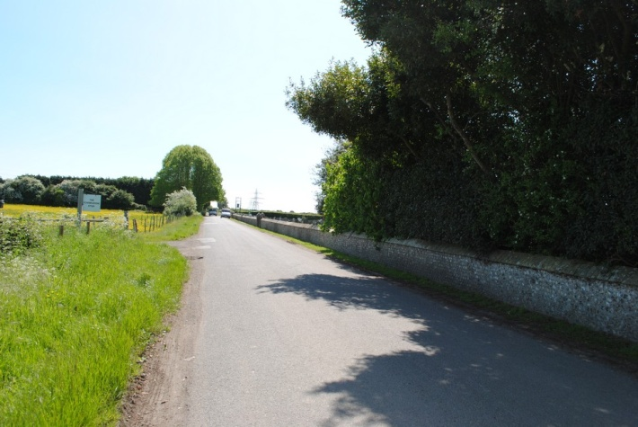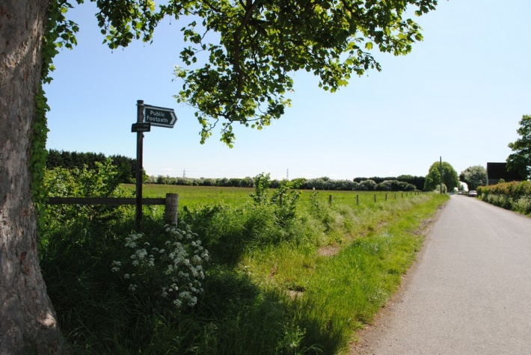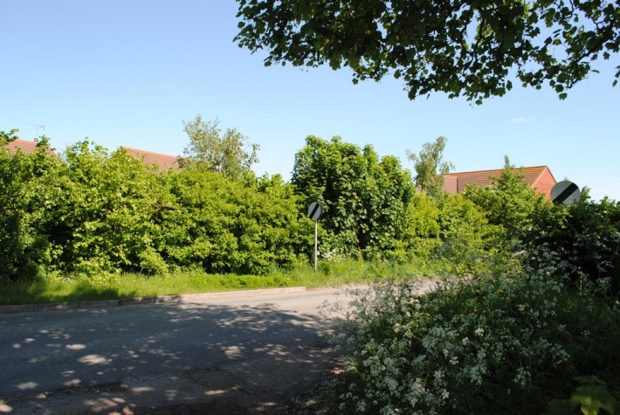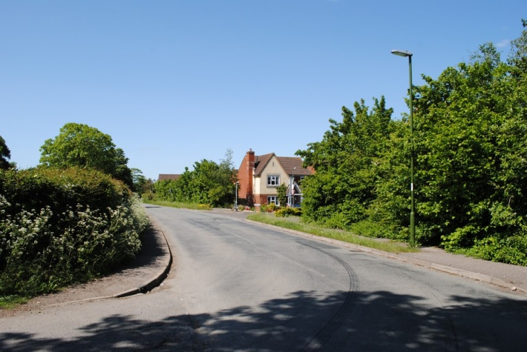
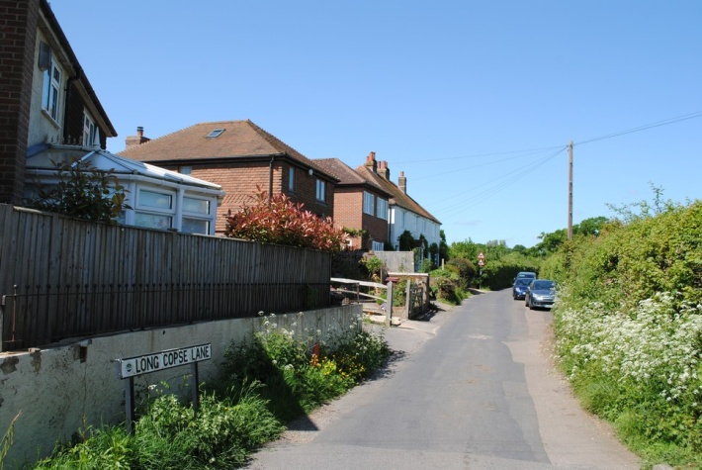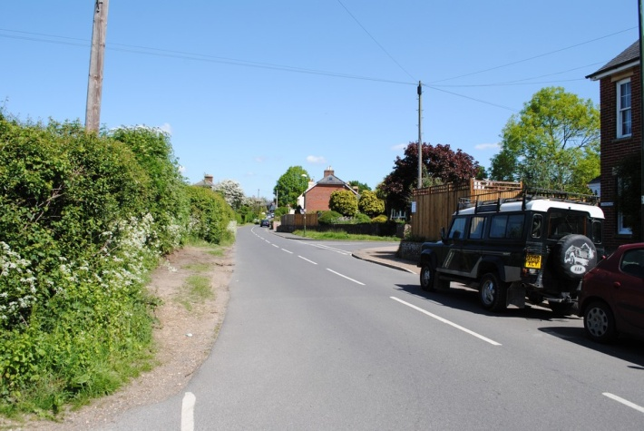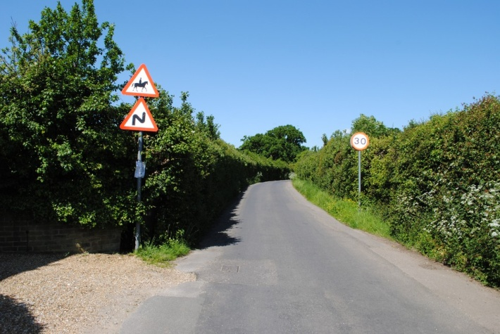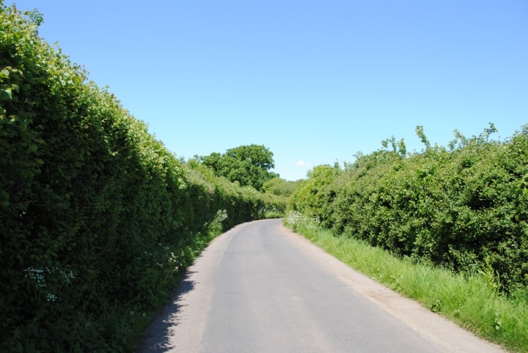
Above; Inter Gap 1 Top Left View Up Long Copse Lane from Monks Hill. Top Right view up Monks Hill Lower 2 pictures are of Long Copse Lane as you leave Westbourne Village
Below; Inter Gap 1 Long Copse Lane photos from the Junction with School lane showing the mixed rural area
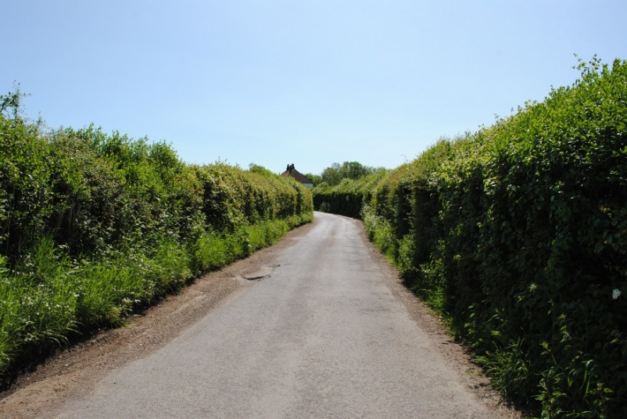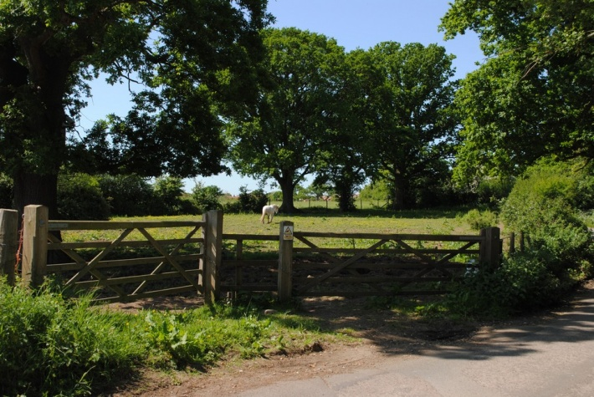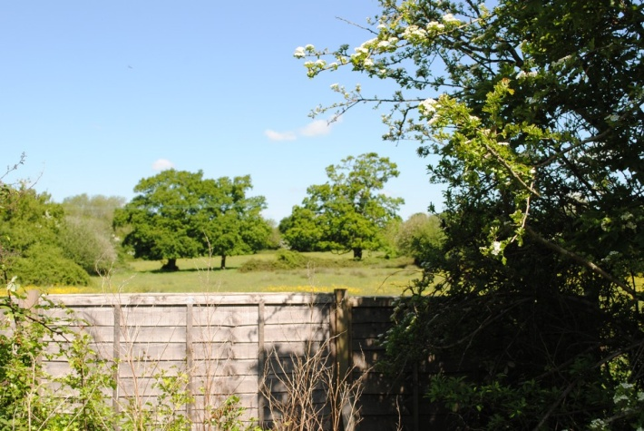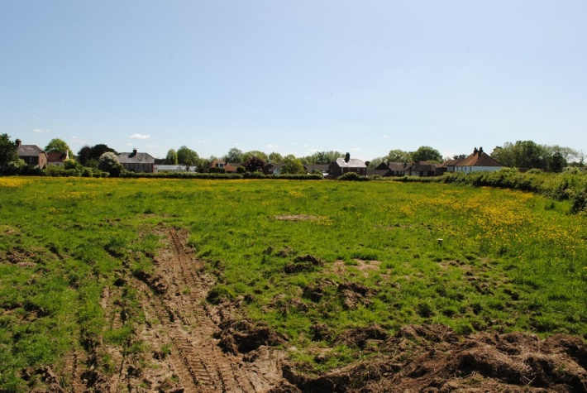

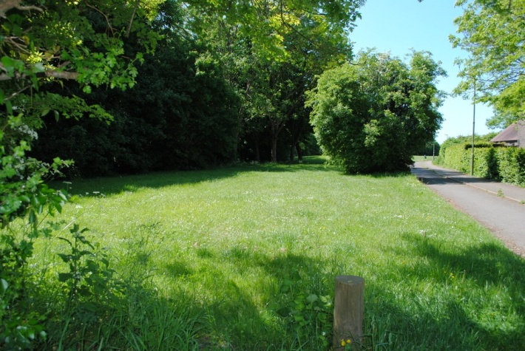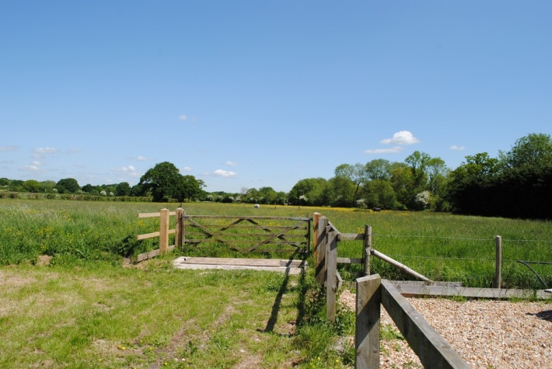
Above; Inter Gap 1; Top Left view at the boundary of Emsworth and Westbourne on Westbourne Road Top Right views from rear of the wren centre looking north across the open field boundary with Westbourne Parish, Inter Gap 1 with Hampshire
Below: Inter Gap 2; Area from New Lane in Westbourne Village out toward Mill Lane Inter Gap 2
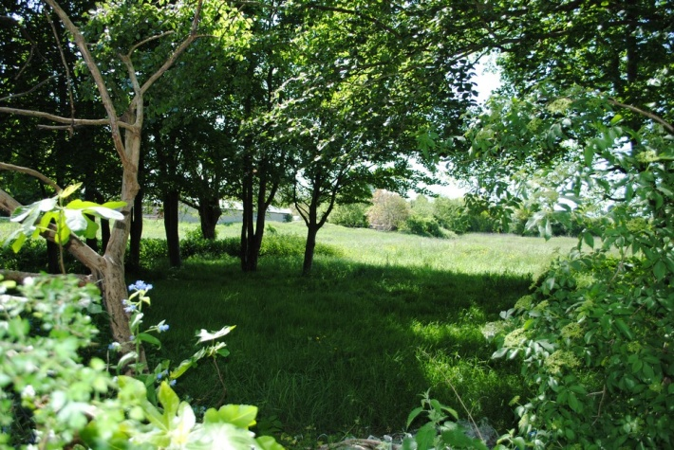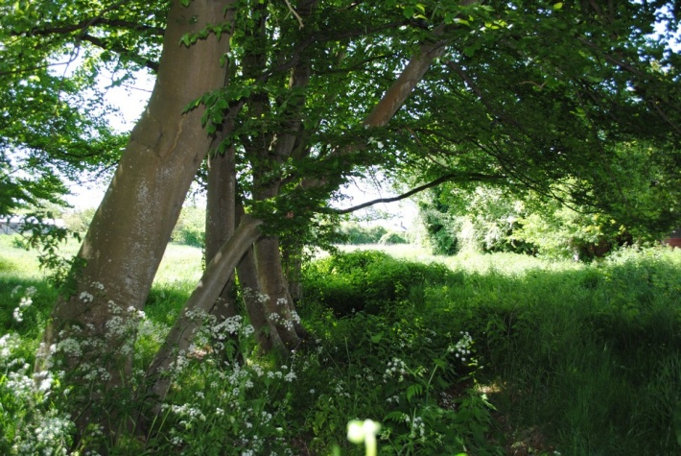
Below: Inter Gap 2; Views Whitechimney, Old Farm Lane Junction demonstrating rural open feel bounded by converted agricultural buildings
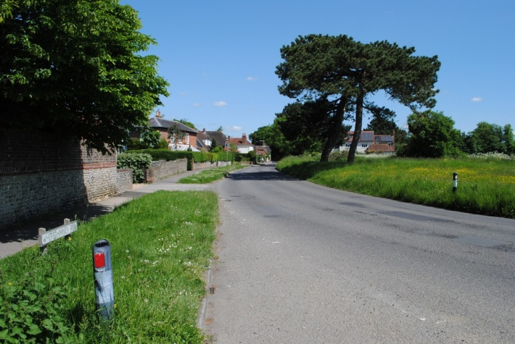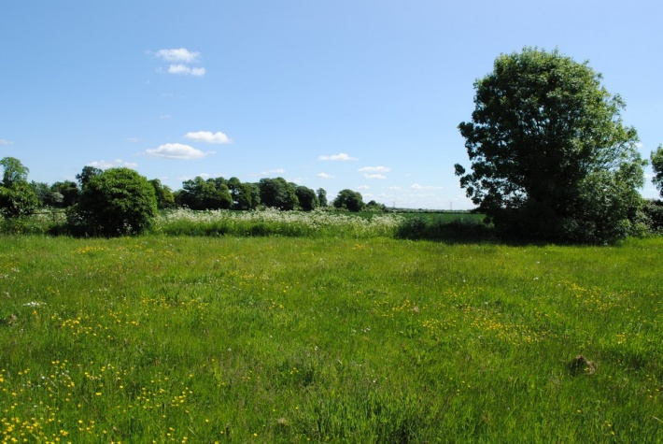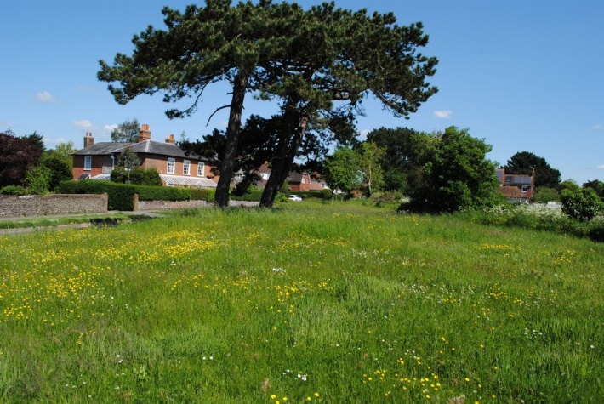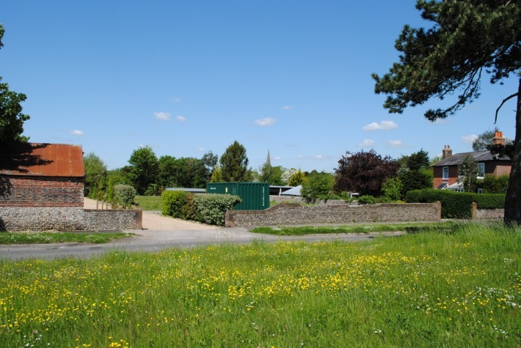

Below; Inter Gap 2 Views along Mill Lane showing open rural aspects bounded by converted barns, established hedgerows views into meadows, crop cultivated land and Chalk stream, an area of abundant wildlife and biodiversity. Footpaths for amenity of locals and visitors.
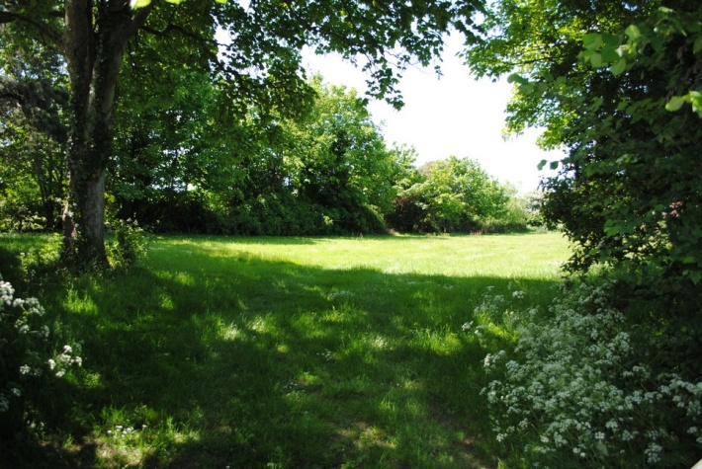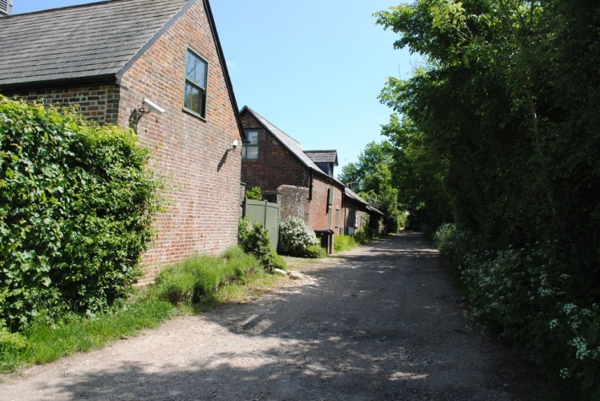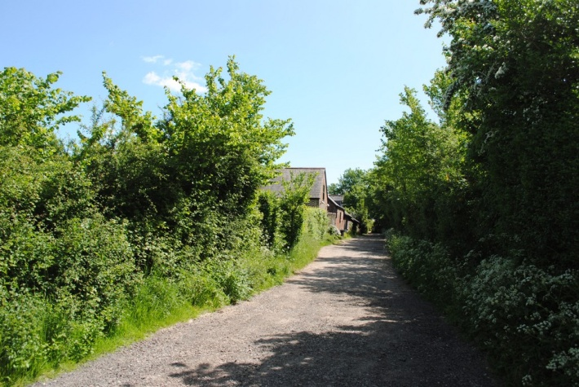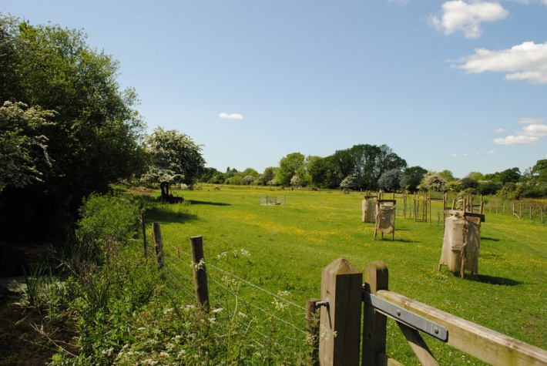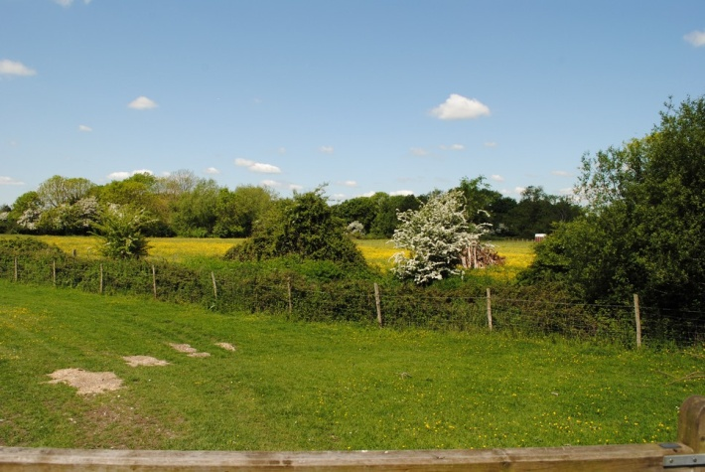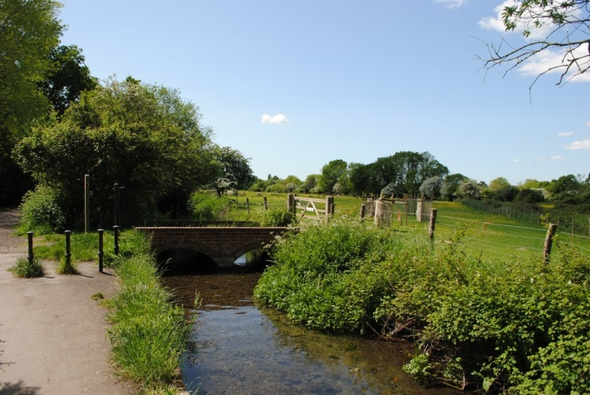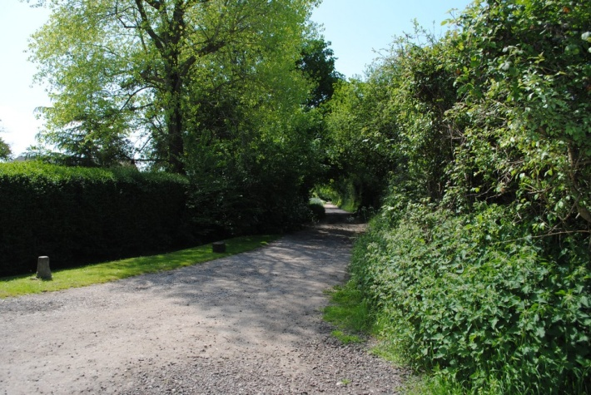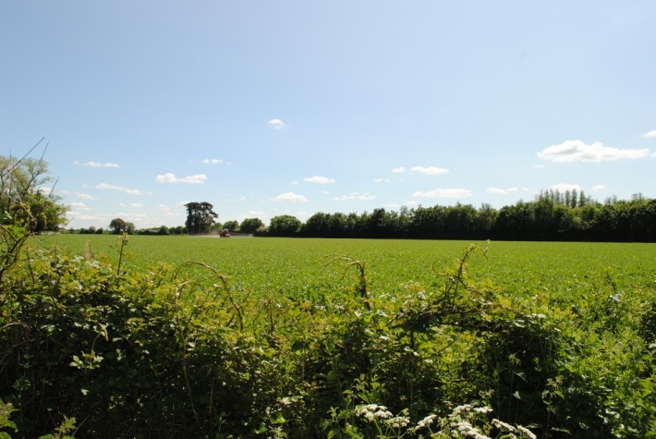

Below: Inter Gap 2; more views from this essential GAP separating Westbourne from Hermitage, including views into the Village across open meadow with Church Spire in the distance.
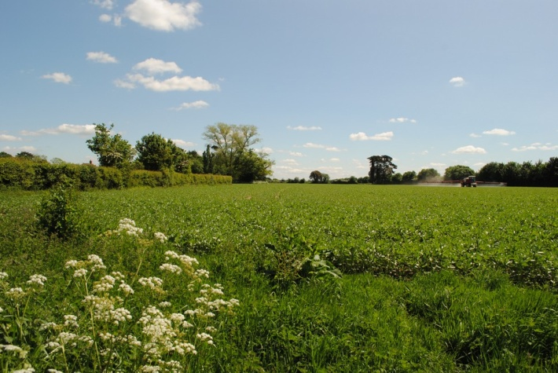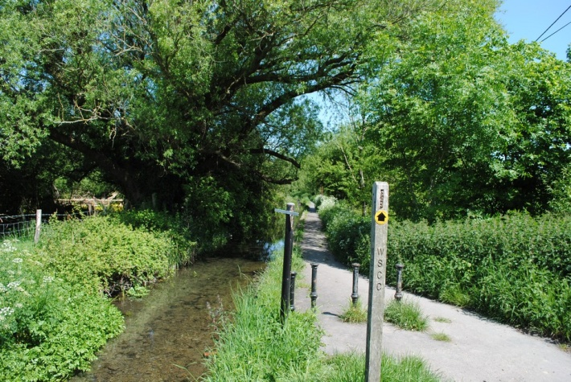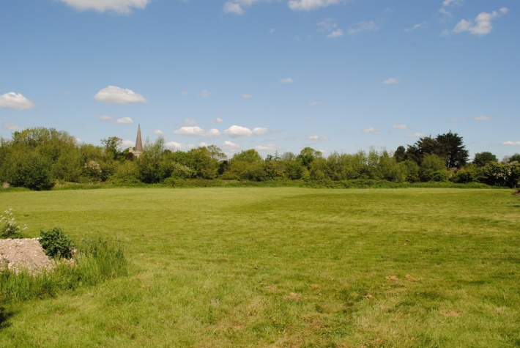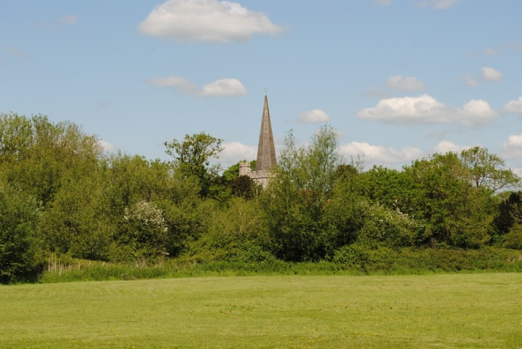
Below; Intra Gap 2; Views as you leave Westbourne along Old Farm Lane views into Intra Gap 2
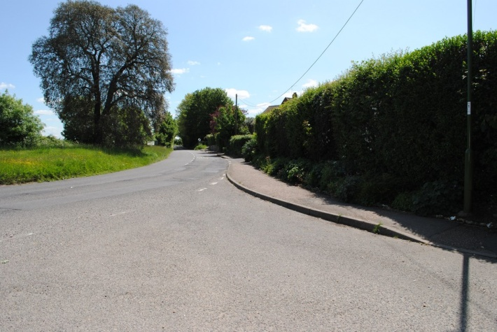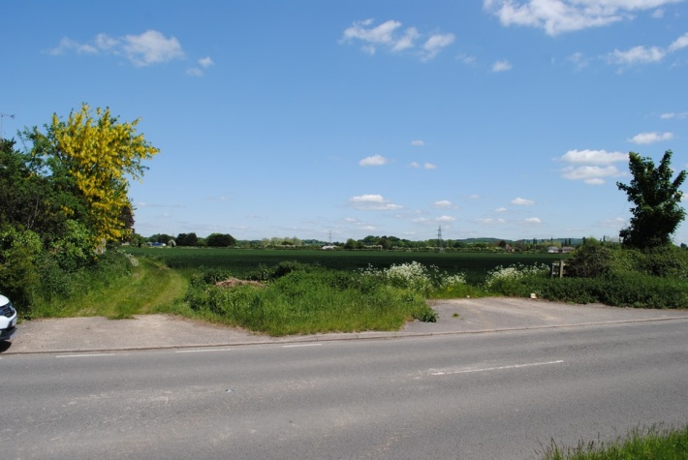
Below; Inter Gap 2; Leaving the Village, views to the right off Old Farm Lane Cultivated Crops
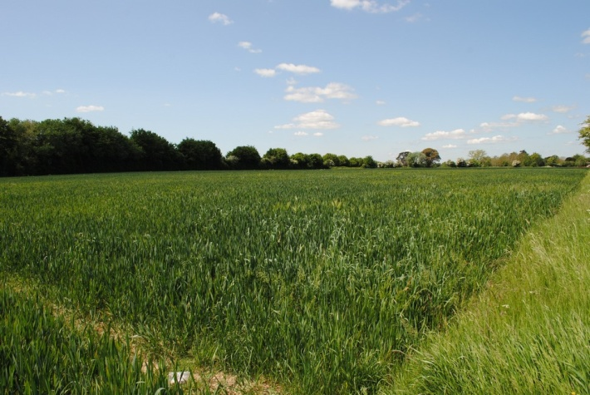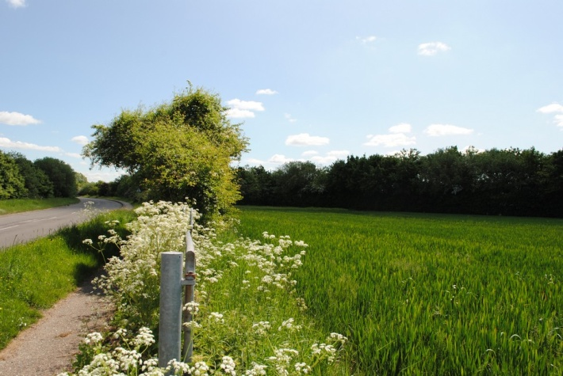

Below; Intra Gap 2; Views from Old Farm Lane toward Cemetery Lane and the Cemetery across cultivated Agricultural Land, giving the sense of open Countryside separation of the 2 distinct areas of Woodmancote and Westbourne.
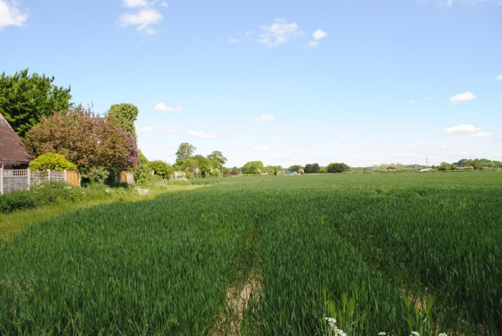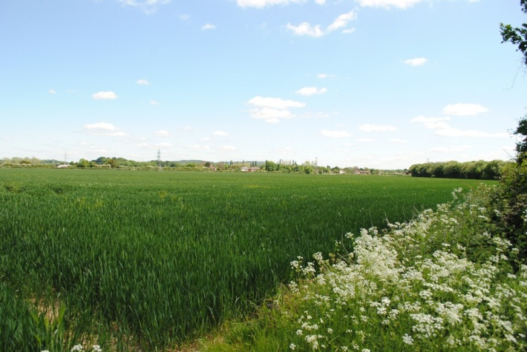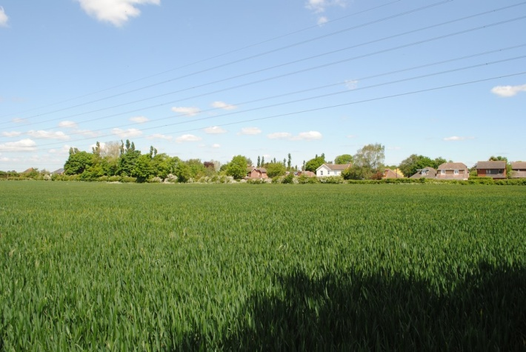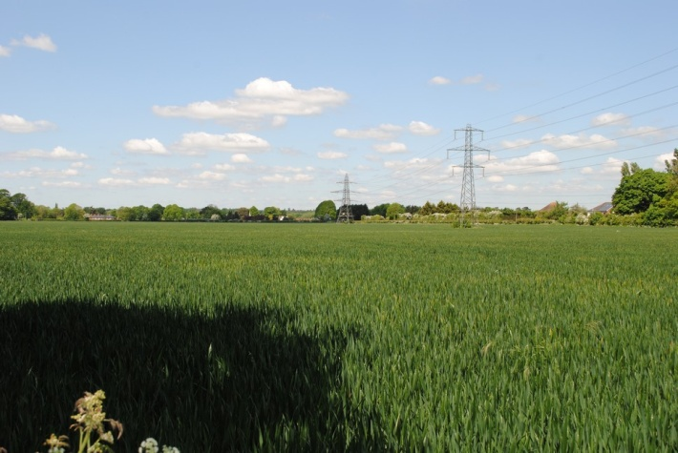
Below; Inter Gap 3; Views of South Lane with Gap bounded by tall thorn hedgerow and open cultivated fields, development of one side of South Lane/Cemetery Lane other side agricultural Land. Giving the feel of separation between Woodmancote and Southbourne.
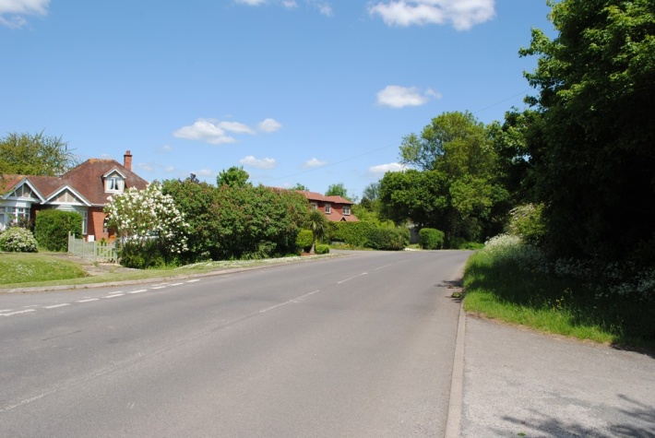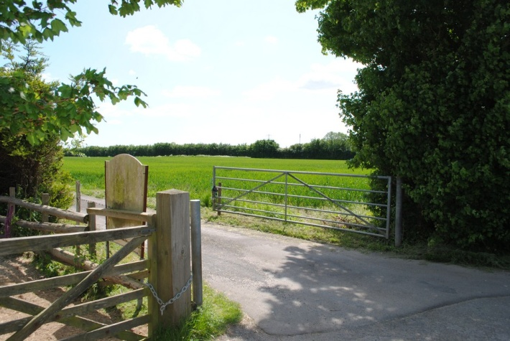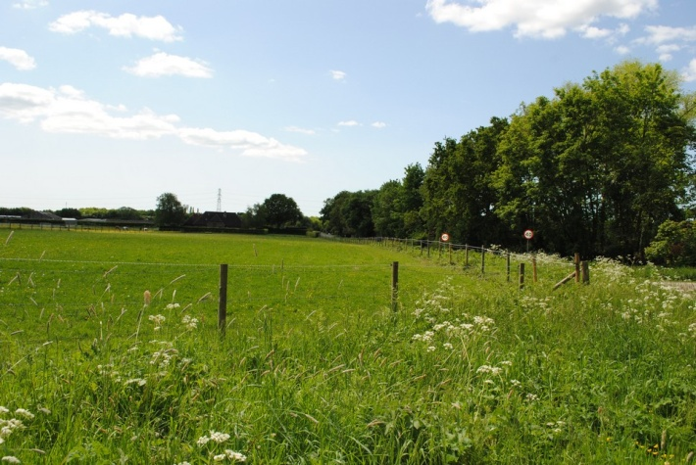

Below; Intra Gap 1; Views from Woodmancote lane looking into Intra Gap 1 in the distance, behind the high tree line on the right in the first picture is Westbourne Village, to the left behind the poplar trees is the beginning of Woodmancote.
