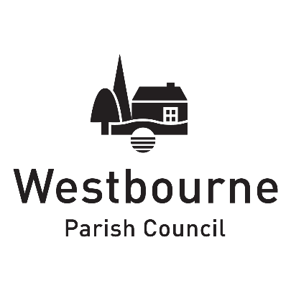

PO Box 143

Emsworth

PO10 9DX

07775 654483

clerk@westbourne-pc.gov.uk

_____________________________________________________________________________________________________

**Members of the Parish Council are summoned to attend Westbourne Parish Council’s meeting which will take place on Thursday 14 September 2023 at 7.15pm at The Meeting Place, North Street, Westbourne.**

Clare Kennett, 8 September 2023

Clerk to the Council

**Agenda**

**1. Apologies for absence**

**2. Declarations of interest**: Councillors are reminded of their responsibility to declare any disclosable pecuniary interest which they may have in relation to any item of business on the agenda no later than when that item is reached. Unless a dispensation has been granted, you may not participate in any discussion of, or vote on, or discharge any function related to any matter in which you have a pecuniary interest as defined by regulations made by the Secretary of State under the Localism Act 2011. You must withdraw from the room when the meeting discusses and votes on the matter, unless the public is entitled to attend, in which case, you may join the public gallery.

**3. Dispensation request**: To consider the circulated dispensation requests from Cllr Franks and Cllr Hitchcock.

**4. Minutes of the Parish Council meeting held on 13 July 2023**: To approve the circulated minutes as a correct record.

**5. Updates and issues from the minutes of 13 July 2023**: To note any updates or issues which are not otherwise on the agenda.

**6. Open forum (maximum of eight minutes)**: To hear representations, questions and statements from members of the public, conducted in accordance with Standing Orders 3(e) to 3(h).

**7. County Councillor’s comments and questions**: To note the circulated report from County Councillor Andrew Kerry-Bedell and receive any updates. To consider the following:

* To note that the Traffic Regulation Order (TRO) for Monk’s Hill has been passed by the County Council. To consider any response.
* To note that the TRO for the one-way section of The Square (East Street) has failed and that a Community Highway Scheme application has been recommended. To discuss how this will be completed.
* To note the recent correspondence about HGVs using Long Copse Lane.
* To consider supporting Westbourne Community Hall with a TRO application for a variation of parking times on River Street outside the building.

**8. District Councillor’s comments and questions**: To note the circulated report from District Councillor Roy Briscoe and receive any updates.

**9. Police incident report**: To note the recent crime statistics at [www.police.uk](http://www.police.uk) (search for Westbourne).

**10. External audit 2022/23**: To receive the report from Moore which concludes the audit for financial year 2022/23.

**11. Internal audit 2023/24**: To approve the appointment of Mulberry & Co as the Parish Council’s internal auditor for financial year 2023/24, see the circulated engagement letter, and to work with Paul Burdick, Accounting for Local Councils & Clerks, to prepare the end of year accounts at a cost of £540 (inc. VAT). The cost would be included in the 2024/25 budget.

**12. Budget monitoring**: To receive the bank reconciliation to 31 August 2023 and to review the budget report.

**13. Payments for approval**: To consider and approve two lists of payments, prepared by the Clerk acting as Responsible Financial Officer. The first is a list of payments due immediately requiring advance authorisation, the second is a list of payments made requiring retrospective authorisation.

**14. Correspondence**: To note the list of correspondence and to consider any required action.

**15. Announcements and items for the next meeting**: To note items brought forward by permission of the Chair. Requests to be submitted prior to the start of the meeting.

**16. Confidential business**: To resolve to exclude the public and press, in the view that publicity would prejudice the public interest by reason of the confidential nature of the business or arising out of the business about to be transacted – Public Bodies (Admission to Meetings) Act 1960.

**17. Mill Road playground inspection report**: To consider the recommendations of the report.

**18. Business Plan 2023-27**: To consider the circulated draft prepared by the Clerk to assist the members in agreeing priorities for the new Council. To agree to spend no more than 20 minutes on the item.

**19. Date of next meeting**: The next meeting is scheduled to be held on Thursday 12 October 2023 at 7.15pm.